
River Kennet Water Level Management Plan

We are the Environment Agency. It’s our job to look after your environment and make it a better place – for you, and for future generations.

Your environment is the air you breathe, the water you drink and the ground you walk on. Working with business, Government and society as a whole, we are making your environment cleaner and healthier.

The Environment Agency. Out there, making your environment
a better place.

Published by:
Environment Agency
Thames Region
Red Kite House
West Area Office, Howbery Park
Crowmarsh Gifford, Wallingford
Oxfordshire, OX10 8BD

Tel: 08708 506506

© Environment Agency August 2006

All rights reserved. This document may be reproduced with
prior permission of the Environment Agency.

WATER LEVEL MANAGEMENT PLAN: REVIEW SIGN-OFF SHEET
GENERAL DETAILS
Site Name: | River Kennet SSSI
Region/Area: | Thames Region, West Area Office
Agency Project Manager: | Paul St. Pierre
NATURAL ENGLAND & ENVIRONMENT AGENCY AGREEMENT TO REVIEWED WATER LEVEL MANAGEMENT PLAN
“I confirm that I agree with the findings and recommendations of this reviewed Water Level Management Plan. I confirm that I believe that the actions set out would achieve the water level management appropriate for securing the favourable condition of the affected units of the SSSI”
Position |  | Name | Signature | Date
Natural England / Natural England Conservation Officer
Environment Agency Area Flood Risk Manager

Summary

Introduction
This Water Level Management Plan (WLMP) Review provides an addendum to the 1999 WLMP for the River Kennet. The aim of the WLMP Review is to ensure that water level management is not a barrier to attaining ‘favourable ecological condition’ within the SSSI. It was agreed that for the River Kennet SSSI, the WLMP Review should focus on the in-channel water level control structures, identifying those in need of replacement or removal, and those needing changes to their management and/or operation.

Due to time and budget constraints in the WLMP Review programme, not all the identified structures can be addressed within this cycle. Therefore this Review will highlight, as a priority for action, those structures or operational practices that are impediments to favourable ecological condition being reached. The prioritisation was performed using the knowledge of key staff in Natural England and the Environment Agency, together with field visits to some of the structures to confirm the length of the affected reaches up- and downstream of the structure.

Actions
Section 10 lists the priority actions for the River Kennet arising from this WLMP Review which are summarised below.

A number of locations have been identified for priority action in this Review. For the majority of these locations, a change in management of the problem structure(s) is required, normally in conjunction with river restoration.

Priority actions for the River Kennet WLMP:
Reproduced from Table 10.2
ID no | Location | Type of changes required
ID 9 (10B/C) | Rags Hatches Axford | Change in management or structure removal
11B and /or C | Offtake to Ramsbury Lake | Change in management
15A-C | Ramsbury Mill (u/s of Howe Mill) | River restoration
19 A-G | Littlecote Fish House | Change in management and river restoration
20B, 21 | Between SU316703 and Chilton Foliat Mill | Change in management and river restoration
22, 23 25B, 25E to H/I | Chilton Estate | Change in management and river restoration
26A-E | Eddington Mill | Management agreement
30 | Avington No 1 | Change in management and river restoration
31A and B | Avington Fishing Hut | Change in management and river restoration
32D | Weed rack upstream of Barton Court | Remove structure
38A-B | Barton Holt | Structure removal

Next steps
This WLMP Review is the first of five stages that will be used to implement water level management improvements for the River Kennet SSSI, with the end deadline of 2010. After the completion of a Costed Action Plan for the identified actions, a feasibility study will investigate the possible options to change the structures at the priority locations and put forward the best solution for detailed design and implementation.

Table of Contents
Summary i
1 Purpose of the Plan 1
1.1 Water Level Management Plan Review 1
1.2 River Kennet Water Level Management Plan 1
2 Site details 3
3 Site layout and features 4
4 Nature Conservation 4
4.1 Conservation interest 4
4.2 Conservation aims 4

4.2.1 Rivers and streams 4
4.3 Conservation management 6
5 Other Land Uses 6
5.1 Within the SSSI 6
5.2 Adjacent to the SSSI 6
6 Hydrology 6
6.1 Geology and soil 6
6.2 Current Hydrological Regime 7

6.2.1 Water level structures 7

6.2.1.1 Structure ID 1 7

6.2.1.2 Structure ID 3C 9

6.2.1.3 Structure ID 4A and 4C 9

6.2.1.4 Structure ID 4B 10

6.2.1.5 Structure ID 5A to 5C 10

6.2.1.6 Structures ID 6 and 8 11

6.2.1.7 Structure ID 7A 11

6.2.1.8 Structure ID 9 (also 10B/C) 13

6.2.1.9 Structure ID 11B - D 14

6.2.1.10 Structure ID 12 14

6.2.1.11 Structure ID 13 E to H 15

6.2.1.12 Structure ID 14A 15

6.2.1.13 Structure ID 15A-C 17

6.2.1.14 Structure ID 16A 20

6.2.1.15 Structure ID 17 20

6.2.1.16 Structure ID 18 20

6.2.1.17 Structure ID 19 A-G 21

6.2.1.18 Structure ID 20B, and 21 24

6.2.1.19 Structure ID 22, 23 25B, 25E to H/I 25

6.2.1.20 Structure ID 26A-E 26

6.2.1.21 Structure ID 27C 29

6.2.1.22 Structure ID 28B 29

6.2.1.23 Structure ID 30 30

6.2.1.24 Structure ID 31A and B 31

6.2.1.25 Structure ID 32A-B 32

6.2.1.26 Structure ID 32D 32

6.2.1.27 Structure ID 33A 33

6.2.1.28 Structure ID 33B-D 33

6.2.1.29 Structure ID 35A 36

6.2.1.30 Structure ID 36B 36

6.2.1.31 Structure ID 38A-B 36

6.2.1.32 Structure ID 44 to 47A 38

6.2.1.33 Structure ID 45B 38

6.2.1.34 Structure ID 46A-E 38

6.2.1.35 Structure ID 47A 38

6.2.1.36 Structure ID 48A 39

6.2.1.37 Structure ID 51B 39

6.2.1.38 Structure ID 56 45

6.2.1.39 Structure ID 57A-C 45

6.2.1.40 Structure ID 58A 45

6.2.1.41 Structure ID 60B-C 46
6.3 Current site conditions 47

6.3.1 Natural England Condition Assessment 47
7 Water Quality 47
8 Water level management objectives and proposals 49
8.1 Water level management objectives 49

8.1.1 Natural England objectives 49

8.1.2 Working principle for the River Kennet WLMP Review 49
8.2 Water level management proposals 49

8.2.1 Change in management / management agreement 50

8.2.2 Removal or replacement of the structure 50

8.2.3 River restoration 50
9 Constraints and impacts on adjacent ground 52
10 Alterations to infrastructure and procedures 52
10.1 Actions from the 1999 WLMP 52
10.2 Actions arising from the WLMP Review 52
11 Other Proposed Action 54
12 Contingency Measures 54
13 Unresolved Issues 54
14 Other Matters 54
15 Consultees 55
References 55
Appendices 56
Appendix A – SSSI Citation 56

List of Tables

Table 2.1 Summary information for The River Kennet SSSI 3
Table 6.1 The Natural England Condition Assessment for the River Kennet SSSI 3
Table 8.1 Changes needed for the problem structures, priority and responsibility 3
Table 10.1 Alterations needed to water courses, structures and procedures from the 1999 WLMP 3
Table 10.2 Priority alterations needed to water courses, structures and procedures from the 2006 WLMP Review 3

List of Figures

Figure 1.1 Water Level Management Plan Review process 3
Figure 6.1 Structures 1 to 8 on the River Kennet 3
Figure 6.2 Structures 8 to 15 on the River Kennet 3
Figure 6.3 Structures 15 to 19 on the River Kennet 3
Figure 6.4 Structures 19 to 27 on the River Kennet 3
Figure 6.5 Structures 27 to 34 on the River Kennet 3
Figure 6.6 Structures 34 to 43 on the River Kennet 3
Figure 6.7 Structures 43 to 51 on the River Kennet 3
Figure 6.8 Structures 51 to 54 on the River Kennet 3
Figure 6.9 Structures 54 to 56 on the River Kennet 3
Figure 6.10 Structures 56 to 58 on the River Kennet 3
Figure 6.11 Structures 58 to 60 on the River Kennet 3

Purpose of the Plan
A Water Level Management Plan (WLMP) provides a means of balancing and integrating the water level requirements for a range of activities within a Site of Special Scientific Interest (SSSI). These activities include agriculture, flood risk management and conservation.

In particular, a WLMP may comprise a written statement that outlines the objectives for a SSSI and how they may be achieved. The plan is endorsed by the operating authority, in the case of the River Kennet SSSI, the Environment Agency, Natural England (formerly English Nature), and, as far as possible, by other parties with an interest in the site.

Water Level Management Plan Review

The Government has set a target for DEFRA to “care for our natural heritage, make the countryside attractive and enjoyable for all and preserve biological diversity by… bringing into favourable condition [or unfavourable but recovering] by 2010, 95 per cent of all nationally important wildlife sites” [SSSIs] (Defra and English Nature, 2004).

Natural England is responsible for monitoring the condition of SSSIs, at least once every six years, using a set of common standards. The first assessment of all SSSIs was completed in March 2003. The Environment Agency has the primary responsibility, as the operating authority, for bringing 64 priority SSSIs in England back to favourable condition, by achieving appropriate water level management. The River Kennet is one of the priority SSSIs.

To achieve the Government target outlined above, the Environment Agency, in consultation with Natural England, will review the existing WLMPs for each of the 64 sites identified. A revised WLMP will be produced for each site with an action plan to implement the WLMP. The Environment Agency has established a WLMP Review process for each of the 64 SSSIs, which is outlined in Figure 1.1.

The purpose of the WLMP Review is to assess the effectiveness of the current plan against the agreed targets contained within it for a range of activities. Information made available since the production of the original plan, changes in the condition of the SSSI and other issues directly or indirectly associated with water management on the site will be considered.

The WLMP Review is the first of five stages that will be used to implement any water level management improvements with the overall deadline being 2010. The five stages are as follows:
- Review of the existing WLMP;
- A costed action plan for a range of options for water level management improvements;
- A feasibility study to consider these options;
- A design study if a technically feasible, economically viable and environmentally acceptable solution is identified; and
- The construction and implementation of the agreed solution.

River Kennet Water Level Management Plan

A WLMP was produced for the River Kennet SSSI in 1999 (Andrews Ward Associates, 1999). This document comprises the Review of 1999 WLMP, and fulfils Step 1 of the review process as displayed in Figure 1.1.

Please note that this document provides an addendum to the 1999 WLMP; it does not replace it. Where information or data have not changed since the production of 1999 WLMP, this is indicated in the text and the reader should refer to the original WLMP.

It was agreed by the Environment Agency and Natural England during the production of the review that the Natural England condition assessment (Section 6.3) was of limited use to this review. Rather, highlighting necessary changes in water level management should be based on recent work including the appropriate assessment of the Kennet and Lambourn floodplain, feasibility studies on river restoration, and Environment Agency / Natural England staff knowledge on river structures.

It was also agreed that the River Kennet SSSI WLMP Review should only focus on the water level control structures in the channels, identifying those in need of replacement or removal, and also those requiring change to their management and/or operation.

Due to time and budget constraints on the WLMP Review programme, not all the identified structures can be addressed within this cycle. Therefore this Review prioritises those structures or operational practices that are impediments to favourable condition being reached.

Working principle for the River Kennet WLMP Review

In addition to the water level objectives of Natural England (see Section 8), the following working principle was agreed by Natural England and the Environment Agency for the River Kennet SSSI WLMP Review:
Aim to ensure at least one continuous stretch of channel in favourable condition with no barrier to fish migration

As the river has many tributaries or braided sections, then ensuring a continuous stretch of channel with unimpeded flow can be achieved using the side streams and channels; the continuous stretch does not necessarily have to always be the main river channel.

The agreed approach was to identify all structures that pose problems, in order to have a record of all structures that need change. It is not possible to tackle all of these structures in the few years leading up to 2010, and so the largest and most important changes need to be prioritised.

This working principle has guided the prioritisation of actions required to structures in order to achieve favourable condition.

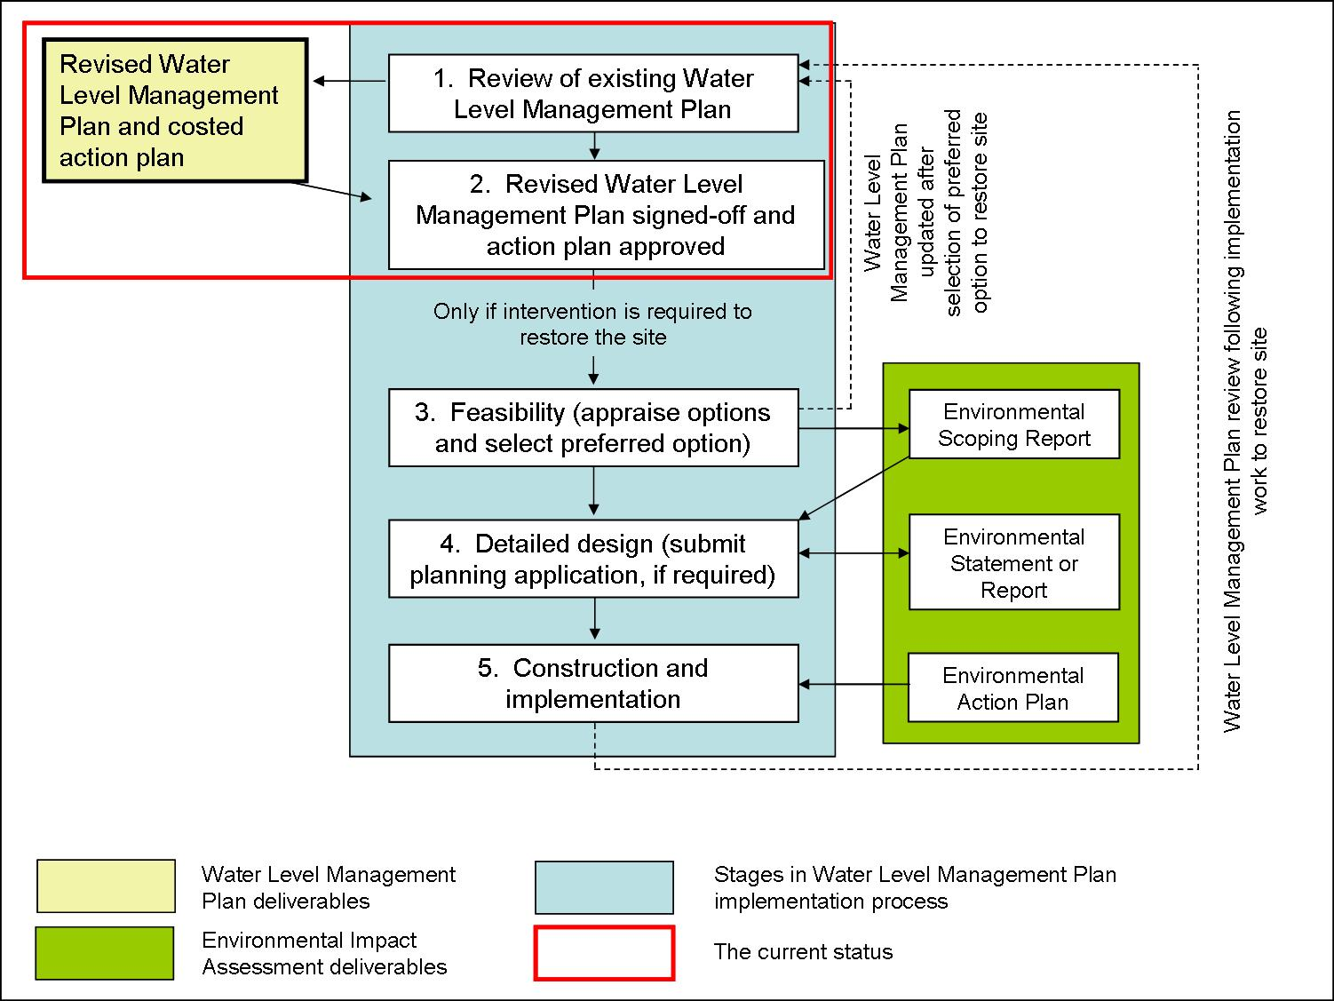

Figure 1.1 Water Level Management Plan Review process

Site details
Table 2.1 Summary information for The River Kennet SSSI
Site Name | River Kennet
Site Status | Site of Special Scientific Interest (SSSI) notified under Section 28 of the Wildlife and Countryside Act 1981
County | Berkshire
Local Planning Authority | West Berks District council
Grid Reference | SU322798 to SU490672
Area of Site (ha) | 27.92 ha 68.99 acre
Date Notified (under 1949 Act) | -
Date Notified (under 1981 Act) | 1 November 1995
Operating Authority | Environment Agency, Thames Region Area, Red Kite House, West Area Office, Howbery Park, Crowmarsh Gifford, Wallingford, Oxfordshire, OX10 8BD
Natural England | Foxhold House, Thornford Road, Crookham Common, Thatcham, Berkshire, RG19 8EL

Site layout and features
The 1999 WLMP describes the layout and features of the River Kennet. In summary, the River Kennet rises north-west of Marlborough, and flows eastwards passing through Hungerford and Newbury before joining the its confluence with the River Thames at Reading. The River Kennet is a lowland chalk stream that progresses to a clay river south of Newbury. The Kennet and Avon Canal runs parallel with the River Kennet downstream of Hungerford, at times sharing the same channel.

The River Kennet SSSI covers the reach between Marlborough to Woolhampton, to the east of Thatcham, and includes a number of back channels. The boundary of the SSSI is the top of the river bank or the first break in slope. The River Lambourn SSSI is a tributary of the River Kennet SSSI, and there are also four SSSIs along the River Kennet which are Freemans Marsh SSSI, Chilton Foliat Meadows SSSI, the Kennet and Lambourn Floodplain SSSI, and the Kennet Valley Alderwoods.

The river catchment is predominantly rural, with some urban areas. Human activity on the river is considerable and includes navigation, flood defence, groundwater abstraction, fisheries (commercial and recreational), sewage treatment works, and agricultural use. The ecological status of the river is considered to be unfavourable; it is thought that the river suffers from over-abstraction with unnaturally low flow in summer, and also nutrient and turbidity problems. Further to this, the river has been proposed as an example of a Heavily Modified water body under the EU Water Framework Directive by the Environment Agency and Defra (Dunbar, 2002).

Water vole

Nature Conservation

Conservation interest

The SSSI citation is presented in Appendix A. Details of the nature conservation interest are given in the 1999 WLMP.

Conservation aims

Natural England has the following views on conservation aims and management for the different habitats found within the River Kennet SSSI. These can be viewed on the Natural England web page for the River Kennet SSSI.

Rivers and streams
Rivers and streams vary widely in character, from dynamic, boulder-strewn, upland streams, to more tranquil, spring-fed, chalk rivers in the lowlands. Each river naturally provides a diversity of habitats for plants and animals (including invertebrates, many species of fish, otter, water vole and breeding and wintering birds). Some of these habitats are directly connected with the physical form of the channel and its banks; others are created by the vegetation which the river’s form supports. The river substrate and its water chemistry vary naturally, depending upon the geology of the river catchment. Despite their varied character, there are some common principles on conservation and management that apply to all rivers and streams.

The physical features of the river or stream (its natural structure and form) should be maintained as far as possible in their natural state. This will support a natural flow regime that will help conserve the geomorphological features of interest. It will also ensure the provision of resting pools for fish, conserve the quality of the riverbed as fish spawning habitat and avoid the creation of artificial barriers to the passage of migratory fish and other animals, such as otters. Natural barriers to the movement of fish (such as waterfalls) should be left alone. Where artificial modifications have occurred - such as weirs and impoundments, embankment, straightening and dredging – the restoration of natural channel profiles and dynamics is desirable where appropriate. Any new infrastructure, such as road and rail bridges should be carefully designed to avoid the constriction of the river or blockage of its floodplain. Opportunities should be taken to create additional riparian areas where flooding is acceptable, in order to reconnect the river with its floodplain.

Management should maintain the natural flow regime of the river or stream, including natural erosion and sedimentation processes, in order to meet the requirements of the full range of flora and fauna it supports. Abstraction levels should be managed to protect the characteristic flow regime of the river, including seasonal base flows and flushing flows. Compensation flows are generally not an acceptable alternative to reducing abstraction, and river transfers may also have an undesirable effect on river ecology.

Bank-side vegetation should be allowed to develop, allowing characteristic plants to flourish as well as benefiting those animals that spend part of their life-cycle out of the water. A mix of trees, bushes, tall and short fen and grass is desirable and can be encouraged by careful management. For example, grass swards are best managed by cutting once or twice a year or lightly grazing with stock at low densities. If it is not possible to reduce stocking densities on bank-side habitats, it may be necessary to consider fencing the bank-side habitat as an alternative measure to addressing artificially exacerbated bank-side erosion caused by excessive trampling by livestock. Associated habitats, such as oxbow lakes, areas of marshland, vernal pools and floodplain woodland, can all be very important for invertebrates and should be considered integral with the river system.

The characteristic aquatic plant communities associated with in-channel vegetation should be allowed to flourish, including fringing emergent vegetation and beds of submerged plants. Any cutting of vegetation should aim to leave at least 50% of the channel vegetated, comprising an active marginal fringe and a mosaic of submerged and floating beds that are allowed to flower and set seed.

Of particular importance for invertebrates are exposed riverine sediments, which include sand and shingle bars or spits as well as eroding banks and river cliffs. The nature of these features is such that they tend to shift and move over time and management should aim to ensure that a similar proportion of exposed sediment is maintained within any given stretch of the river. The invertebrate communities associated with exposed riverine sediments are sensitive to excessive shade, compaction by grazing livestock and mechanical activity and management should aim to keep most areas of exposed sediment free from these impacts. Where appropriate, any coarse woody debris within the river channel should be left in situ. As well as providing a valuable habitat for certain invertebrate species, it can also promote the deposition of river shingles behind the debris and can generally increase in-channel structures, which are of benefit for invertebrates.

Any exploitation of fish populations or other native animals or plants should be at a sustainable level, without manipulation of the river’s natural capacity to support them or augmentation by excessive stocking. Where stocking is carried out it should be done such that it does not compromise the genetic integrity of natural populations, which can be a particular issue where existing fish populations have not previously been subject to stocking.

In common with other freshwater systems, rivers and streams are susceptible to the introduction of invasive species such as non-native plants and animals, for example, mink and signal crayfish. The introduction of non-native plants and animals, including fish, should be avoided. Invasive species such as Japanese knotweed and Himalayan balsam should also be controlled.

The maintenance of good water and sediment quality are essential to maintaining a healthy river system. Management should minimise pollution of the river from point and diffuse sources, including discharges of domestic and industrial effluent, run-off from agriculture, forestry and urban land and accidental pollution from industry and agriculture. Siltation of the river bed can smother and infill coarse gravels, which can affect fish spawning success and the establishment of submerged plants such as water crowfoot, as well as having an impact on the invertebrates living in and on the riverbed. Riparian areas and the wider catchment need to be managed sensitively to avoid excessive run-off of soil particles and nutrients into the river. Ploughing should not be allowed to destabilise river banks and an unploughed strip of at least 2m should be left adjacent to the riverbank. Nutrient enrichment and organic pollution result in the decline of plant, invertebrate and fish communities. Effluents entering the river directly or indirectly should be treated to reduce the levels of phosphorus contained within them to concentrations that will not lead to a proliferation of algae or the disappearance of characteristic plants and animals. Organic pollution should also be controlled to avoid de-oxygenation of the water or any toxic effects on aquatic animals and plants.

Conservation management

The river is largely managed as a fishery with in-stream and marginal vegetation maintained to allow access and improve in-stream habitat. Several landowners have implemented restoration schemes to improve in-stream habitat, using various techniques to narrow over widened reaches and re-introduce sinuosity and geomorphological diversity to sections that have been engineered in the past.

Other Land Uses

Within the SSSI

The 1999 WLMP contain details on the responsibilities of the Environment Agency with respect to flood control and weed cutting. It also describes other activities that take place including fisheries, abstractions and discharges, navigation, flow gauging and access points (fords).

Adjacent to the SSSI

The 1999 WLMP contains details on the land uses adjacent to the SSSI which include amenity areas (lake), disused water mills, shooting, fisheries, other SSSIs, road and rail networks, settlements and industrial areas.

Hydrology

Geology and soil

There is no additional information on this topic to that in the 1999 WLMP.

Current Hydrological Regime

The 1999 WLMP details the hydrological regime of the River Kennet SSSI, and the interaction of the river and the Kennet and Avon Canal.

Water level structures
The 1999 WLMP contains detailed information for all the water level control structures along the River Kennet, at 60 locations along the river.

As stated in Section 1.2, this WLMP review focuses on those structures which have been identified to have some impact upon river flow and water level and therefore preventing the attainment of favourable ecological condition. The structures have been considered in view of the working principle for the Review i.e. trying to ensure at least one continuous stretch of channel in favourable condition with no barrier to fish migration.

As stated in Section 1.2, time and budget constraints on the WLMP Review programme means that not all the identified structures can be addressed within this cycle. Therefore each structure has been ranked (priority, low priority) according to the need to make changes. The ranking procedure which was performed using the knowledge of key staff of Natural England the Environment Agency, together with field visits to some of the structures.

All the identified structures are described in the following sections, giving the account from the 1999 WLMP and current thoughts. Photographs of structures are presented, where available, from the 1999 WLMP and from field visits in 2006. Figures 6.1 to 6.11 map the structure locations along the River Kennet.

The proposals for changing the structures are brought together in Sections 8 and 10.

Structure ID 1
Priority | Low priority
Description | Elcot Mill, Marlborough
Grid reference | SU204692
1999 WLMP comment | Downstream of Marlborough at the start of the SSSI. Two wooden hatches set into brickwork at Elcot. The hatches are kept continuously open to maintain water within the main river Kennet. The structures were formerly used as part of a series to flood the adjacent water meadows up and downstream. Part of these meadows, upstream of the SSSI, is now a poplar plantation. The other part, fed by a SSSI channel has been effectively blocked by stones which block the inflow. Nevertheless some seepage does occur and spring flow also supports it. If the hatches were shut then water would overtop the stones and the meadows would flood. The bottom of the sluice at maximum opening is 123.4 mAOD.
2006 Review comment | This is an old undershot sluice structure which is no longer operational. The river upstream is free-flowing as far as the old railway crossing (200 m) and the sluice does not present an obstacle to fish movement. There is scope for restoration, if required, to open up an old channel which flows to the east of the mill and which could be used for brown trout recruitment. This remnant channel rejoins the main river 200 m downstream of the mill. For this to operate successfully, the old sluice structure may need to be restored to give the necessary control over the flow split. John Hounslow is the River keeper.
Actions needed | Consider the benefits of restoring the structure to open up the back channel fro the benefit of brown trout and associated chalk river features.

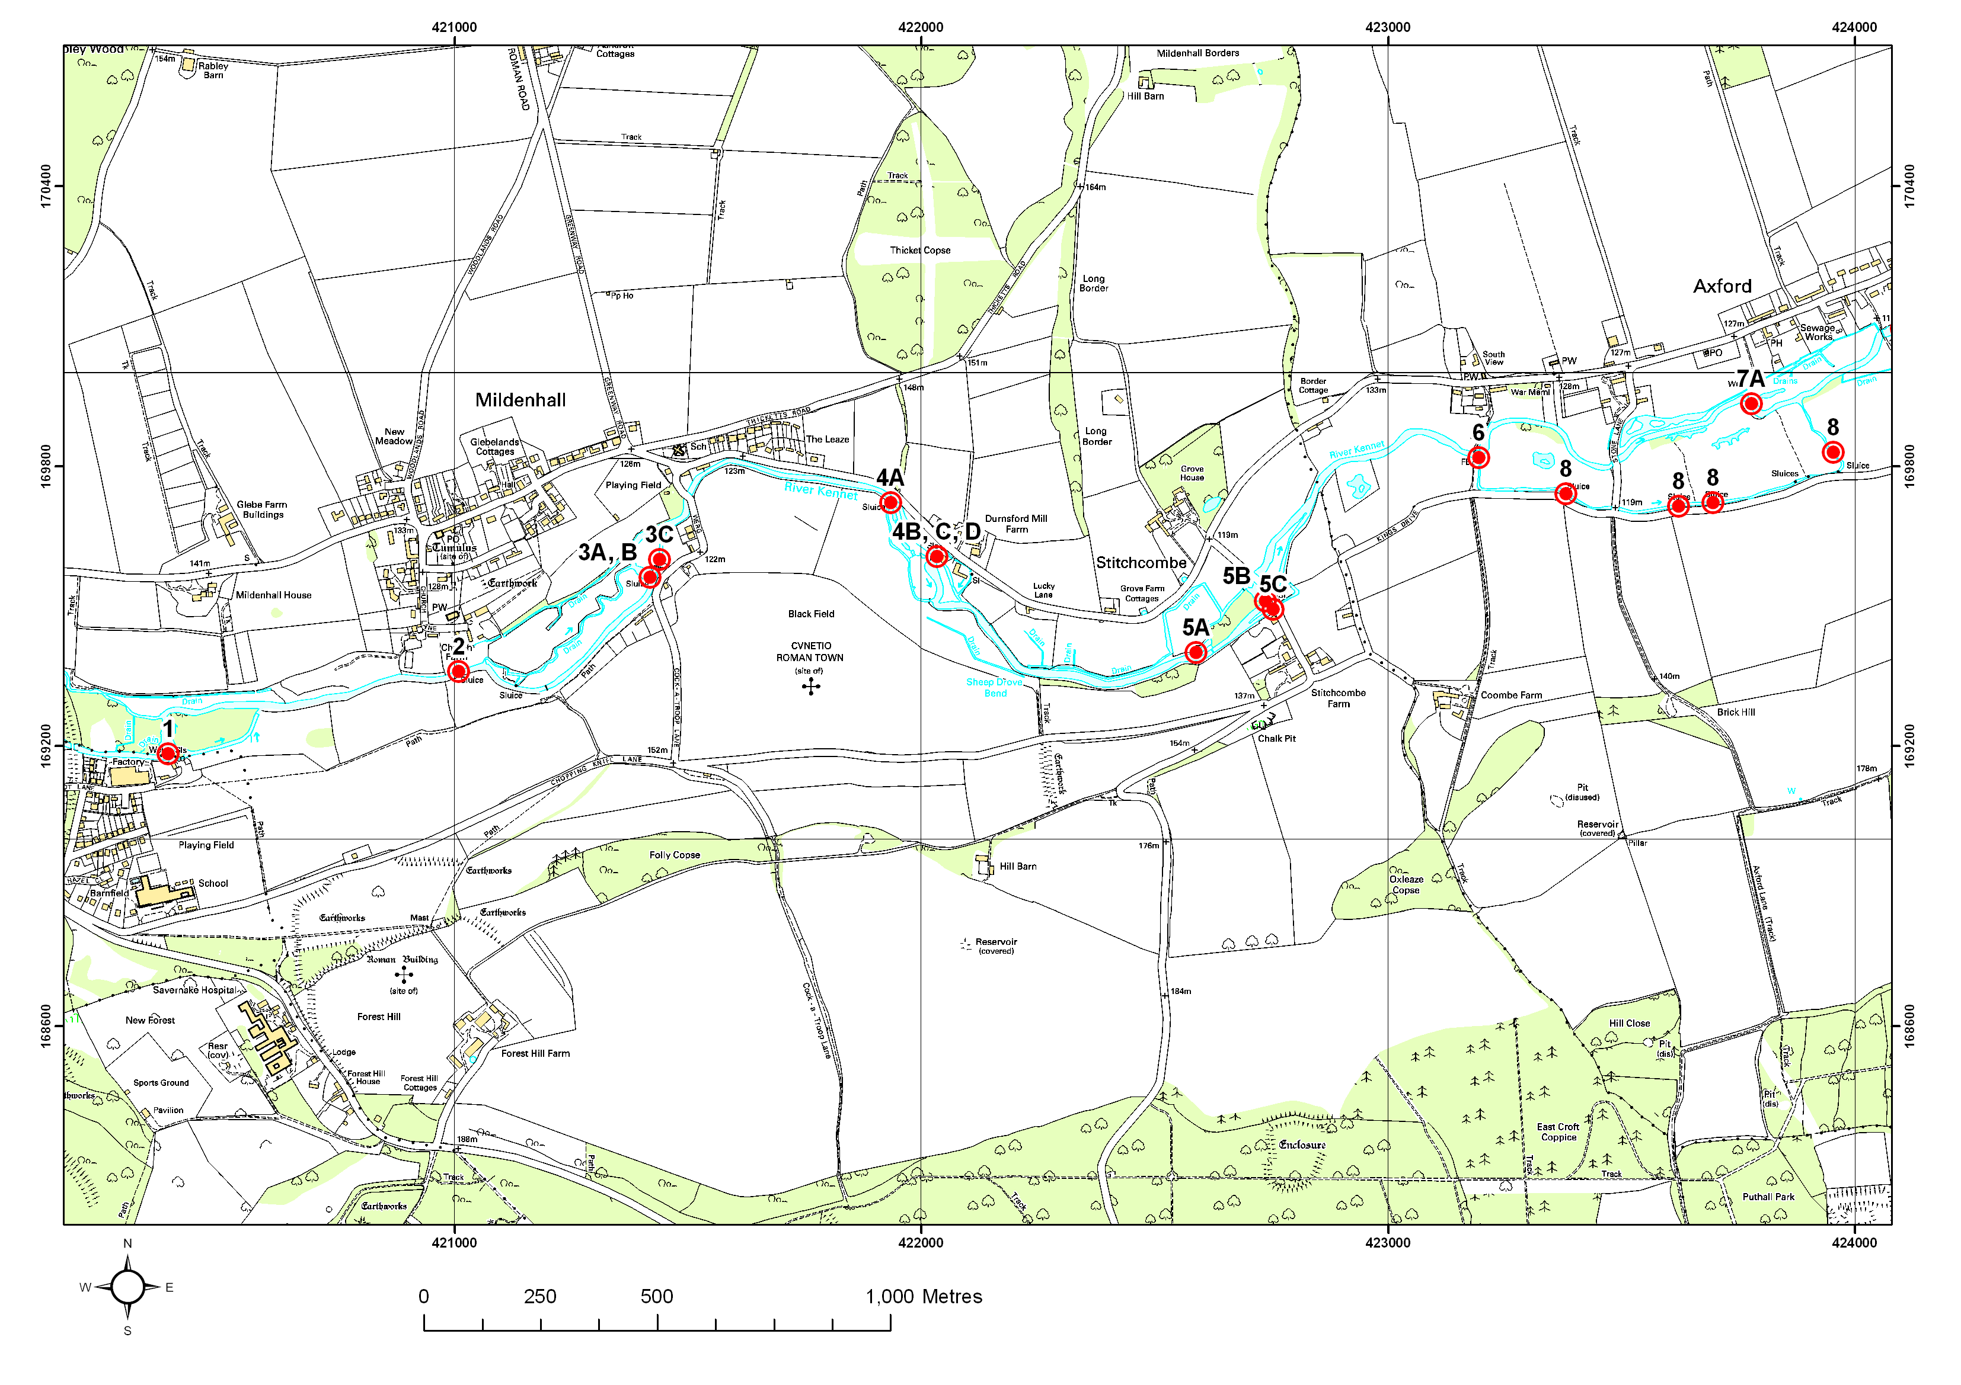
This map is reproduced from Ordnance Survey material with the permission of Ordnance Survey on behalf of the Controller of Her Majesty’s Stationery Office © Crown copyright. Unauthorised reproduction infringes Crown copyright and may lead to prosecution.
Figure 6.1 Structures 1 to 8 on the River Kennet

Structure ID 3C
Priority | Low priority
Description | Werg Mill, Mildenhall
Grid reference | SU215696
1999 WLMP comment | Collection of structures by Keepers Cottage at Mildenhall.  3A: Main structure of four wooden hatches with a wooden footbridge over taking the main flow and dropping into a mill pond. The hatches are kept open for 7-8 months of the year and are closed off when the Ranunculus has become established in May or June. If no weed has developed by then, the structure is kept open. Maximum opening of the structure 122.4 mAOD.  3B: The structure to the old mill channel is managed by means of boards within the concrete structure to act as a weir. The boards are managed to keep approximately 5% of the flow passing down the mill channel to act as a sweetener.  Upstream of 3B is a disused hatch which was used to take the water off to flood the meadows by Keepers cottage. This was achieved by lowering 3A to raise the head and opening this hatch. No levels data are available.
2006 Review comment | The structures are still in operation and being managed by the river keeper, John Hounslow. The river upstream is not badly impacted by the sluice and fish appear able to move freely between reaches. By allowing more water to pass through Structure 3C there is scope to open up the old, original, channel downstream of it and improve brown trout recruitment. This channel has been used successfully for incubation box work. In order to open up the channel, Structure 3C, under the fishing hut, would need to be restored in order to control the flow split adequately.
Actions needed | Change in management to allow more water through the structure, and renovation of the structure if necessary.

Structure ID 4A and 4C
Priority | Low priority
Description | Durnsford Mill, Mildenhall
Grid reference | SU219697 (A) and SU 221698 (C)
1999 WLMP comment | Structures at Durnsford Mill.  4A: Brick sluice with wooden boards used to provide a sweetener to the back (SSSI) channel. It is opened during periods when the weed is cut. No levels data available.  4C: Water passes under the mill, via a weed screen, over a fixed crest, level unknown.  4D: Above the mill on the left hand bank is a small hatch, kept open which feeds a channel formerly used to feed water meadows below the mill and now feeds back into the main channel as a bypass. No levels data are available.
2006 Review comment | The structures are still operating and managed by the river keeper, John Hounslow. There is a small side sluice upstream of the main set, and a further set passing under the Mill. The river upstream was dredged following the 1976 drought and it is the dredging work rather that the presence of the sluices which has the dominant impact on the river.  To restore the river to its pre-1976 condition would require bed replacement from Durnsford Mill upstream as far as the houses below Mildenhall bridge, approximately 600 m. This measure, taken in conjunction with more active management of Durnsford sluices, would have a beneficial effect on the river and fish populations, and would open up two small streams to trout recruitment (downstream of Structures 4A and 4C).
Actions needed | Feasibility study to investigate the options to restore the river bed to pre-dredging condition, changes in management and channel enhancement to improve flow and fish habitat.

Structure ID 4B
Priority | No Action Required
Description | Durnsford Mill, Mildenhall
Grid reference | SU 221698
1999 WLMP comment | 4B: Main overflow at Durnsford Mill. Renovated recently and comprising a fixed weir (approximate level 120.6 mAOD) which is only overtopped in extreme conditions. There is also a moveable structure comprising 4 wooden hatches. The top opening level of this is 121.1 mAOD. The structure is managed to provide a stable head in the canalised section above the mill and to maintain a flow for the house below the mill.
2006 Review comment | The structure creates an impoundment upstream, but good Ranunculus growth has been reported in the affected reach for some years which implies that the impoundment does not have a major deleterious impact on the river. The river keeper manages structure well.
Actions needed | None

Structure ID 5A to 5C
Priority | Low Priority
Description | Stitchcombe Mill
Grid reference | SU228695 (B, C)
1999 WLMP comment | 5A: Entrance to weedpit controlled by boards in blockwork.  5B: Mill bypass. Comprising 3 wooden hatches which were renovated in 1998/1999. These are held open for approximately 7 months of the year and are then lowered in May/June to maintain a head approximately 0.5 m above the natural run. There is a head of approximately 1.5 m above the mill pond. The maximum opening of the hatches is 119.4 mAOD. There is a grassed overflow adjacent to the hatches but Mr Hounslow has not seen water over this for approximately 20 years, as it flows across the river bank before this can happen.  5C: Water enters the mill race over a small weir. The mill race only receives water in high flows or when the water has been held up by the hatches. The channel below the mill (part of the SSSI) was virtually dry in November 1997 and July 1998. The race formerly powered a turbine. No levels data are available.
2006 Review comment | The structures at Stitchcombe Mill are still in operation and managed by the river keeper, John Hounslow. They are managed well but do create a degree of upstream impoundment. The channel has not been dredged and rehabilitation work has been done in certain stretches. A possible option to improve the river would be the restoration of the side sluices to take flow under the road and re-join the main channel 100 m downstream. This would require management changes to open up Structure 5C to allow flow down the side channel.
Actions needed | Change in management and reinstatement of side sluices to allow flow down the side channel, and associated river restoration.

Structures ID 6 and 8
Priority | Low Priority
Description | Kings Drive, Axford
Grid reference | Structure 6: SU232698  Structure 8: SU234698, SU236698, SU237698 and SU239698
1999 WLMP comment | 6: Sluice and spillway upstream of Axford. The structure comprises four hatches within brick retaining walls, one hatch being missing, and a spillway which is managed to regulate the flow of the Kennet and the back channel (also SSSI). At the time of the site there was a head of approximately 0.7 m. The spillway was approximately 3 m wide. The hatches are wooden and there is a top opening height of approximately 117.9 mAOD. No details are available on the operation of these structures.  8: Series of small derelict structures on the back (SSSI) channel. All are approximately 1 m wide and comprise brickwork with a space for boards. There were probably used to flood the water meadows to the north.
2006 Review comment | The river upstream of Structure 6 has been subject to the 2002 enhancement scheme, the Upper Kennet Restoration Project, funded by Thames Water. Some control over water levels in this reach could have significant benefits to the back channel that flows alongside Kings Drive and re-joins the main river in Axford, approximately 1 km downstream. The structure is in poor condition, and leaky, but woody debris in the river means that the flow is impeded as if the structure was working properly. The controlled flow is beneficial to a very good nursery channel, so the structure should be replaced and water should flow down the channel to the south. This channel hosts the derelict Structure 8 which should be removed (an easy job). Any further restoration work to this channel restoration work would largely consist of fencing off the channel from cattle and tree works to reduce shading.
Actions needed | Structure 6 needs to be replaced or renovated and Structure 8 removed. Fencing should be installed to prevent cattle access to the channel to the south.

Structure ID 7A
Priority | Low priority
Description | Red Lion Hatches, Axford
Grid reference | SU238699 (A) and 241701 (B)
1999 WLMP comment | The structures at Axford comprise 4 wooden hatches which at the time of the site visit in October 1997 were all open. Additionally there are two slots for hatches which are not present. This structure controls the flow between the main Kennet and the back stream which runs parallel and was probably a feed to water meadows. The top opening level of the hatches is 116.2 mAOD.
2006 Review comment | The structures do create an impounding effect, although it is not thought this is greatly significant. Consideration could be given to removing the structure in the future, with subsequent bed reprofiling and river narrowing.
Actions needed | Remove the structure and restore river channel. Changes to Structure 7A should be made with consideration of changes to Structure 9 (below).

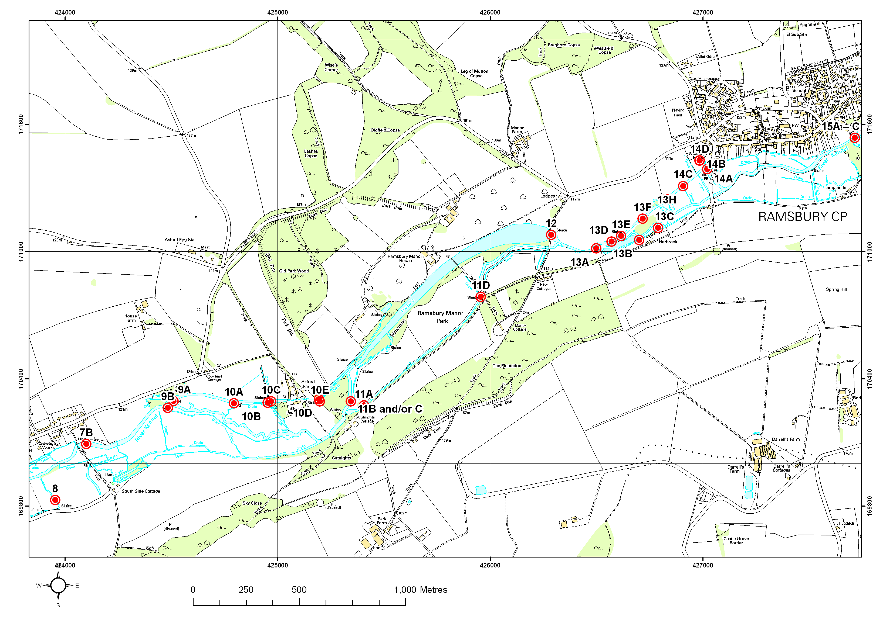
This map is reproduced from Ordnance Survey material with the permission of Ordnance Survey on behalf of the Controller of Her Majesty’s Stationery Office © Crown copyright. Unauthorised reproduction infringes Crown copyright and may lead to prosecution.
Figure 6.2 Structures 8 to 15 on the River Kennet

Structure ID 9 (also 10B/C)
Priority | Priority
Description | Rags Hatches Axford
Grid reference | SU245703
1999 WLMP comment | Two sets of structures with a footbridge below Cowleaze Cottages.  9A: Over the back channel is a derelict structure with 2 hatches, approx 1 m wide. Now containing one board approx 20 cm high and the other 2 boards, approximately 40 cm high. A small back channel joins downstream of this structure with evidence of old brickwork.  9B: The structure controlling flow to the main Kennet comprised 3 hatches two of which were partly open in October 1997. No levels data are available as existing cross sections do not match the structures present.
2006 Review comment | This is a multiple structure controlling flows down the main river and down the high level channel leading to Priory Farm. A further small set of side structures send flows from the high level channel back to the main river with the rest continuing through a water wheel at the farm, and then into a set of ponds supporting exotic birds in Ramsbury Manor grounds. The water then flows into the main lake at the Manor and joins the Kennet at the lake outfall.  All of these structures upstream of Priory Farm are operational and are controlled by the estate. The section of the Kennet upstream of Rags Hatches was dredged post 1976 and has suffered significantly as a result. The river is overwide and overdeep with the substrate dominated by silt.  It would be beneficial to the SSSI if we could reduce the flow down the high level channel; an element of flow must continue down here to support the artificial lakes within the grounds of Ramsbury Manor (although this is not the key feed for the large lake in the grounds). The gradient of the reach upstream of (9A and B) needs to be increased, along with narrowing works to improve the in-stream habitat. The presence of the structures effectively reduces the gradient; there is a drop of 1m+ to the weir pool downstream of Structure 9B. Structure 9B also prevents free movement of fish.  Structure 9B could be removed or at least made more passable to fish. Assessment of the levels will be necessary because we must maintain a flow down the high level stream. It may be possible/necessary to change the bed and bank profile of this channel in order to implement a solution. Water voles are present in the high level channel.
Actions needed | A feasibility study is needed to examine options for improving the river through changes in structure management/removal, restoration (including narrowing and bed re-levelling) and increased fish passage. It is essential that enough water passes along the higher level channel and through Priory Farm to maintain a supply for the artificial lake within the grounds.

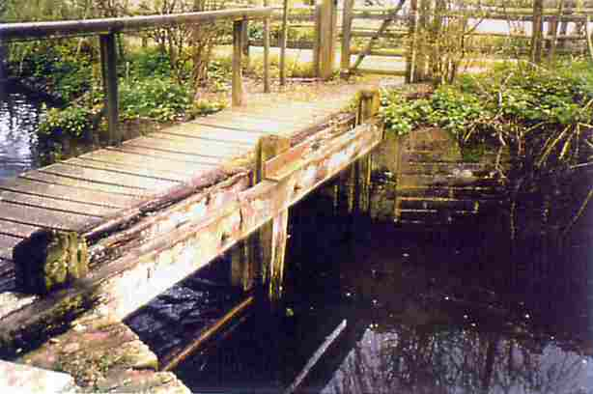
Structure 9A downstream of Axford showing boards in place

Structure ID 11B - D
Priority | Priority
Description | Structures at offtake to Ramsbury Lake
Grid reference | SU254703
1999 WLMP comment | 11B: Four wooden hatches, each approximately 0.9 m wide and with the bottom of each hatch at approximately 114 mAOD when fully open. These allow water to pass from the lake feeder (non-SSSI) and are the main control into the lake.  11C: A set of three hatches which take water from the lake feeder (non-SSSI) and thence to the lake. They are used particularly in high flows.  11D: A weed rack on the main Kennet channel.
2006 Review comment | This is a multiple set of structures controlling the flow split down a straight man-made bypass channel to the south (between Structures 11B and D), and into the Ramsbury Lake via the original river channel. These structures are operated by the Ramsbury Estate. The bulk of the flow of the river passes into the lake, and at low flows the by-pass channel is starved of water to protect the lake level. Above the lake the channel is joined by the flow that comes down from Priory Farm (Structure 10D).  The priority here is to change the operating regime so that less flow enters the Lake and more passes down the bypass channel to the south. This bypass channel is of insufficient size to accommodate the bulk of the flow unless significant works are undertaken to increase and re-meander the channel to create a more natural river. Lake levels will be maintained by the sluices at the bridge at the eastern end. As a result there would be water quality benefits to the river downstream of this point as there are issues associated with the water rejoining the river from the lake outflow such as turbidity, suspended solids and algae. There is the option of installing a sediment trap on the lake outfall but that it may not be effective due to the fine particle size of the suspended sediment. It is recommended that Natural England promote the use of a boom on the Lake to the landowners.
Actions needed | Change in management to retain more water in the river and associated river restoration. The bypass channel would need works to it to improve the habitat. Changes to these structures should be made with consideration of changes at Structure 12.

Structure ID 12
Priority | Low Priority
Description | Weir and Sluice, Outfall from the Ramsbury Lake
Grid reference | Ramsbury Manor Lake SU264711
1999 WLMP comment | A large structure, under the provisions of the Reservoirs Act 1975, comprising the outfall from the Ramsbury Manor Lake into the River Kennet. In October 1997 there was a considerable volume of water coming over the structure with a head of approximately >2 m. There are four fixed crest weirs under the road bridge and six wooden hatches within the sluice structure in the centre of the road bridge. The sill level of the sluice is 111.07 mAOD while the weir sill is lower at 110.8 mAOD. Maintenance on the structure has recently taken place. Adjacent to the main sluice is a small sluice from the lake. This was operated by boards but the outflow from the lake, which had been temporarily blocked for many years, has now been formally closed under the direction of the Panel Engineers under the Reservoirs Act to ensure that there is no danger of water escape. The function of this sluice is uncertain. Since before the Second World War, the Ramsbury Manor Estate has used it only to release silt from the lake. The owners of Harbrook House believe that it was also used to flood the meadows opposite.
2006 Review comment | This structure controls the volume of water leaving the Ramsbury Manor Lake and thus the lake level. It would need to be managed in conjunction with any agreed changes to the operation of the offtake for the lake (11B,C and D)
Actions needed | Manage in conjunction with changes agreed to operation of lake offtake. Use of a boom is suggested to prevent algal build-up on the lake discharging into the Kennet

Structure ID 13 E to H
Priority | No Action Required
Description | Complex of structures at Harbrook
Grid reference | SU266711 (E), 266712 (F), 268713 (G), 269714 (H),
1999 WLMP comment | The complex comprises the structures which feed the back channel (part of the SSSI), and the lake at Harbrook (non-SSSI), impound the lake and also feed water from the Kennet to the back stream via a series of SSSI drainage ditches.  13E: Three hatch structure parallel to the main Kennet acting as the outfall for water coming from the water meadows. Each hatch is approximately 75 cm wide and is kept very slightly open under all conditions to provide a sweetener taking approximately 5% of the flow. No levels data are available.  13F: A wooden groyne/fish pass has been placed in the river. No levels data are available.  13G: Single wooden hatch (75 cm) taking water from the river on the left bank, passing it under the river and releasing it on the right bank. A sweetening flow always passes through the hatch which is opened wide during periods of high flow. Adjacent to this is a derelict structure. No levels data are available.  13H: Brick sluice now with boards in taking water to feed the side channel (SSSI). No levels data are available.
2006 Review comment | There may be the possibility of passing more flow into the south channels as it is good grayling nursery habitat, but only as part of a habitat scheme on the upper channel.
Actions needed | None

Structure ID 14A
Priority | Low Priority
Description | Moons Mill, Ramsbury
Grid reference | SU270714
1999 WLMP comment | Overflow used in winter with space for two sets of dropboards. No levels data are available.
2006 Review comment | Moons Mill is a large mill structure which has a significant impounding effect on the river upstream. The majority of the flow goes down the main side sluice into the weir pool. At the time of this review, renovation work was being carried out on this structure, immediately in front of, and under, the Mill House. The works involve removing the two 12 inch pipes under the House, which frequently becomes blocked, to create a wider conduit. The narrow slit in the bottom part of the structure is also being widened to create a larger undershot weir which will help pull through some of the silt and alleviate the problems it creates. A new overshot structure is also being installed adjacent to the narrow slit structure to help clear the water surface of debris.  There is a need to maintain high water levels in the reach immediately upstream of the Mill House to ensure water spills over a weir (in the right hand bank of the main channel, looking downstream) to feed a downstream pond. The upstream reach could benefit from channel enhancement measures to e.g. increase gradient and pinch flow, make it less straight and more meandering, and remove shading.  There is potential for in-channel improvements upstream of the Mill including tree works to allow more light penetration to the river which would help Ranunculus to increase.
Actions needed | Agree an operating procedure for the new and existing structures to try and relieve the impounding effect. This would be done in association with upstream restoration works. Investigate methods of fish passage.

Structure ID 15A-C
Priority | Priority
Description | Three sets of sluices at Ramsbury Mill (u/s of Howe Mill)
Grid reference | SU278715
1999 WLMP comment | 15A: Mill bypass comprising four hatches, all wooden, approximately 1m wide with a footbridge over the top. The head of water retained by structure is approximately 1.25m. The maximum opening of the structure is 109.25m. The structure is opened at times of high flow to allow silt to be removed from the base.  15B: Immediately in front of the mill are two wooden hatches, each approximately 70cm wide which leak slightly. As with 15A these may also be opened to allow silt to be removed.  15C: Opposite 15A on the left bank is a single wooden hatch which controls water to the back (SSSI) channel. This channel takes water from above Ramsbury Mill to GR280715.
2006 Review comment | This is a major structure affecting a significant length of the river upstream. The structure is comprised of sluices passing underneath the mill (condition unknown but there is some limited operational capacity); a side set of undershot sluices, in poor but operational condition, feeds the bulk of the flow into the main mill pool. There are also a number of side sluices feeding into wetlands to the south. One of these has been used successfully for brown trout incubation box work in the past. The main sluices at the Mill also control flows down a minor channel that flows along the Newtown road through a number of residential gardens. This probably joins the Aldbourne near Knighton. The main sluices are controlled by the owner, James Dallas, who is keen on restoration and is a Trustee of the Thames Rivers Restoration Trust.  There are lots of gardens that back onto this impounded upstream reach. Therefore any changes to the management of the Ramsbury Mill structures would need consultation with landowners on how this will affect river at their property. Changes in operation of the structures would have a limited effect on the river. An alternative proposal would be to cut a new channel. There is a channel (not on the OS map) into which more flow could be passed to bypass the Mill. Any drop in levels at the mill would need to be mindful of the feed to the small stream that runs to the north of the mill and through the village.  A feasibility study is required to look at the options available to significantly reduce the impact of this impoundment. It is thought that the main flow could be diverted down a side channel that leaves the river upstream of the mill and re joins to the south of the weir pool. This would help reduce the impounding effects and allow fish passage. The impounded reach runs in front of several large properties and seeking agreement from all these owners may be problematic.
Actions needed | A feasibility study is required to investigate the options available to significantly reduce this impoundment, including using a by-pass channel to avoid the mill, and bed and bank re-profiling to enhance the chalk river features.

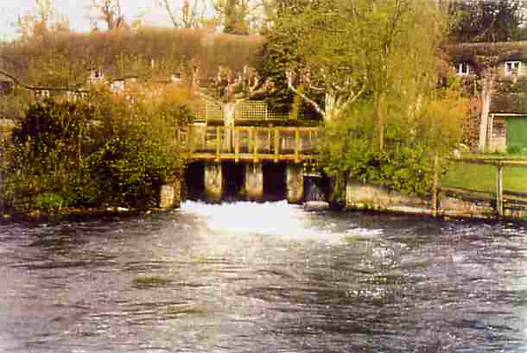

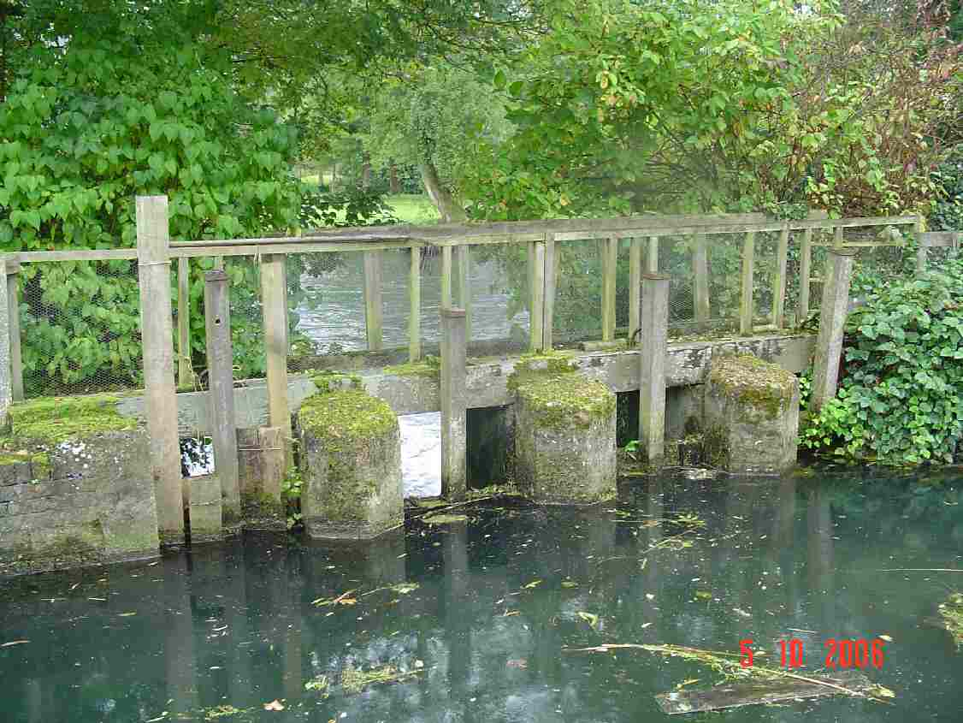
Structure 15A at Ramsbury Mill (above: 1999, below: 2006)

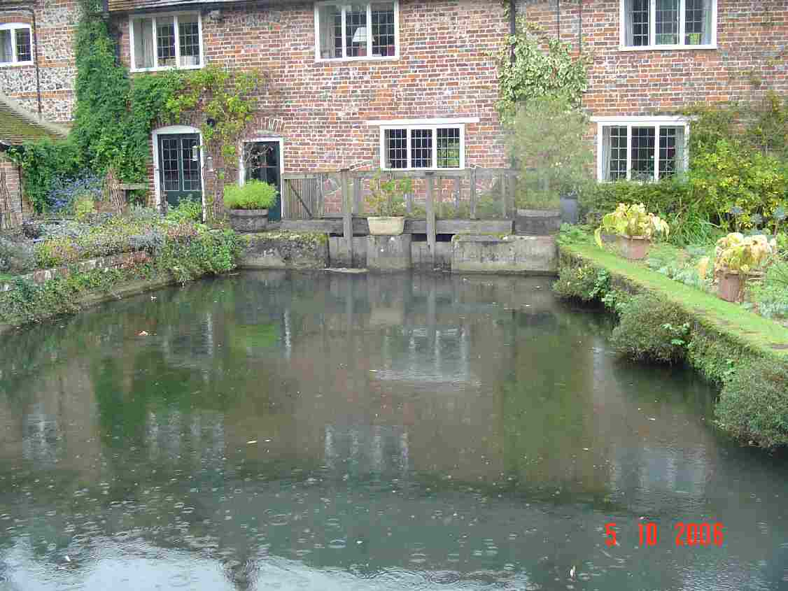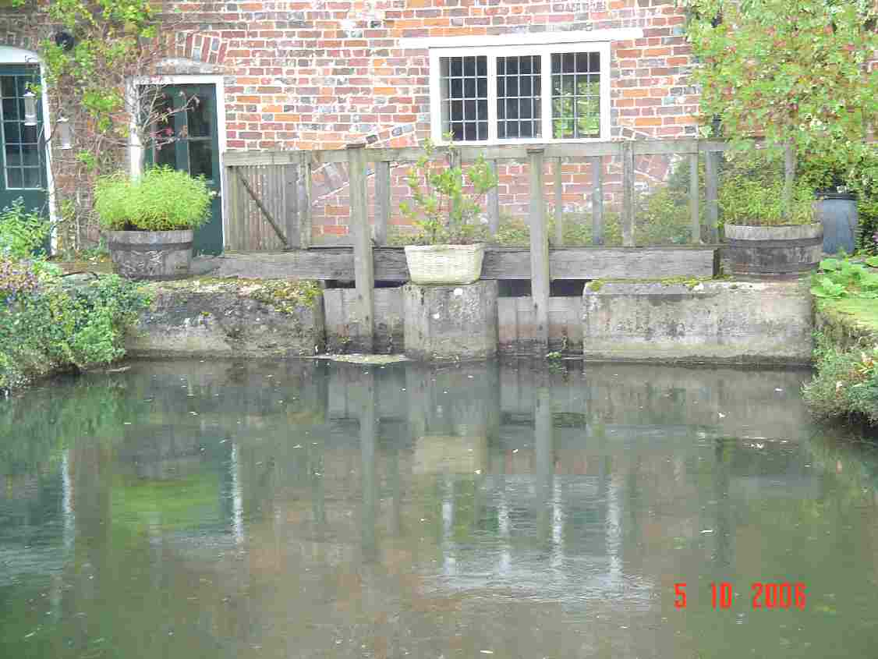
Structure 15B at Ramsbury Mill (left: long shot, right: close-up, 2006)

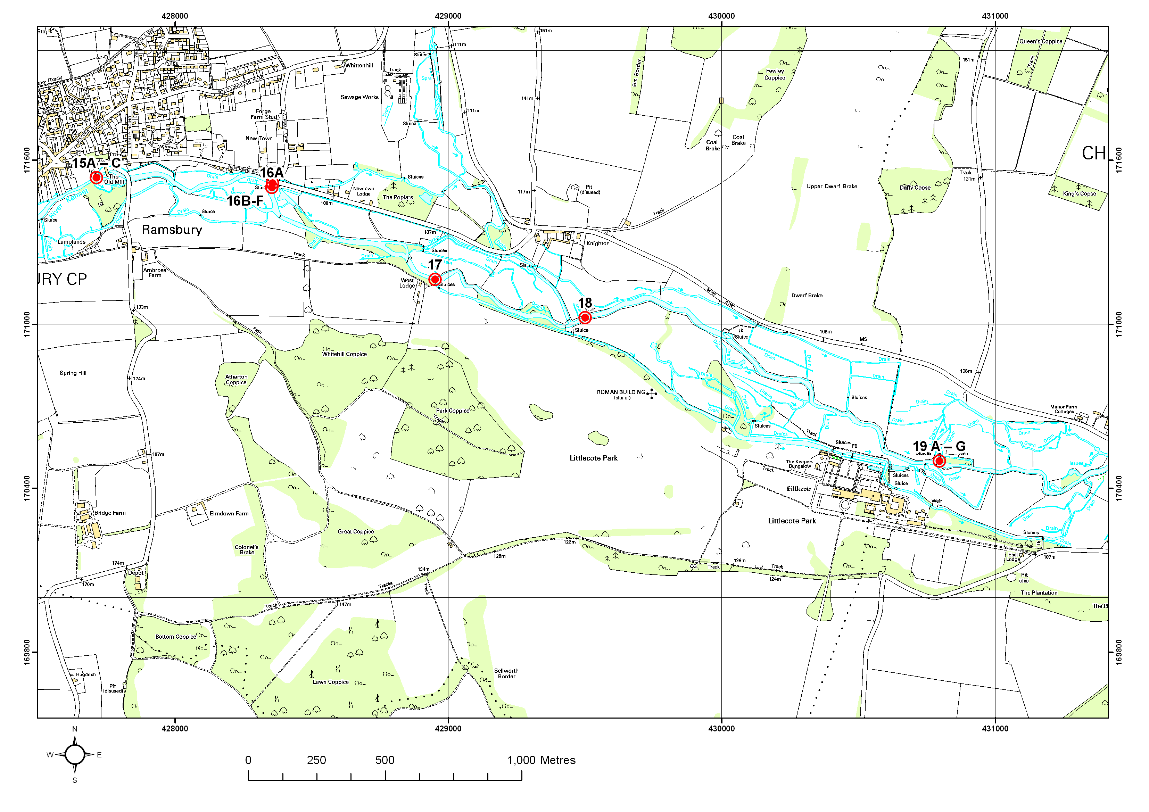
This map is reproduced from Ordnance Survey material with the permission of Ordnance Survey on behalf of the Controller of Her Majesty’s Stationery Office © Crown copyright. Unauthorised reproduction infringes Crown copyright and may lead to prosecution.
This map is reproduced from Ordnance Survey material with the permission of Ordnance Survey on behalf of the Controller of Her Majesty’s Stationery Office © Crown copyright. Unauthorised reproduction infringes Crown copyright and may lead to prosecution.
Figure 6.3 Structures 15 to 19 on the River Kennet

Structure ID 16A
Priority | No Action Required
Description | Structures at Howe Mill
Grid reference | SU284715
1999 WLMP comment | A sluice with provision for three hatches. One wooden hatch is present, one space apparently has no hatch and one space contains a board. Each hatch space is approximately 1 m wide with the bottom of the hatch at maximum opening being 108.1 mAOD. The sill level is 106.93 mAOD and there is a head of approximately 1.5m. The structure is managed to maintain a flow through the Kennet. In times of low flows the hatches are shut down and a slight flow is maintained through one hatch to keep the silt moving.
2006 Review comment | The structure does have an impounding effect on the river. The sluices are operational and can be controlled by the river keeper. The river between here and Structure 11 was part of the Upper Kennet Rehabilitation Project.  A number of side sluices upstream send flows to the south and join up with minor streams some of which originate from above the Old Mill. This is a highly complex system of old water meadow channels which continue along the valley to Littlecote. There is a fish survey site here. This is a well managed stretch by river keeper: no changes necessary in this reach.
Actions needed | None

Structure ID 17
Priority | Low Priority
Description | Sluice by West Lodge
Grid reference | SU289712
1999 WLMP comment | Structure on the main Kennet with 6 wooden hatches and a footbridge over. Each hatch is approximately 1 m wide. The sill is 105.5 mAOD and the bottom of each hatch at maximum opening is 106.4 mAOD. Derelict structures are present on non-SSSI channels which are heavily choked but which join the Kennet downstream.
2006 Review comment | This is a major structure designed to provide water to the water meadow system between here and Newtown. The sluices are operational and are controlled by the Littlecote Estate river keeper, Peter Woolnough, who generally runs these sluices as open as possible. The side channel leading off from the sluices takes water to supply some duck ponds for shooting and there is an on-going water quality problem with regard to the number of ducks present on this stream. If the West Lodge structures are retained they could give benefit to the wet meadow system between the river and the Knighton to Ramsbury road to the north, though some restoration of the carrier streams would be necessary. The public footpath crossing this site creates an ideal partnership project with local landowners and the community.
Actions needed | Management agreement. Possible restoration of carrier streams

Structure ID 18
Priority | No Action Required
Description | Knighton Gauging station
Grid reference | SU295711
1999 WLMP comment | This is a gauging weir comprising two crump weirs which are on telemetry with a fixed main weir crest of 104.94 mAOD.
2006 Review comment | The Knighton gauging station is a weir that causes a degree of impoundment but it is unlikely to be removed due to its importance in collecting river flow data.
Actions needed | None

Structure ID 19 A-G
Priority | Priority
Description | Littlecote Pump House
Grid reference | SU307705
1999 WLMP comment | A series of structures are present north of Littlecote House. These are described in full in the Chilton Foliat Meadows WLMP. At the pump house there is a structure on the main river (19A) with a side hatch (19B). There are two overflow channels (19C/D) and two offtakes (19E/F) for water to feed the meadows. The westerly overflow (19C) comprises three wind up gates allowing water to flow to the south through a small overflow channel (<1 m wide) returning to the river within 100 m. The overflow weir (19D) to the north is an up and over gate with a weed screen allowing water to return to the river through a channel approximately 1.5 m wide. Additionally, immediately above the up and over weir are two offtake channels. The northerly one (19E) comprises a wind up hatch which feeds a channel joining to the Aldbourne distributary. The southerly (19F) is a part derelict fixed structure which feeds water into a blocked off channel. Above these structures, is an offtake (19G) operated to maintain a flow of water through the stew ponds, returning to the river through a broad ditch which is approximately 3-4 m wide.
2006 Review comment | These are the main structures that take water from the river for Chilton Foliat meadows SSSI. They cause a lengthy upstream impoundment (back to Structure 18) and a change in management is needed with associated river restoration. This structure is of relevance to both the River Kennet and Chilton Foliat SSSIs. The structures would historically have supplied flows to the water meadow system between here and Knighton. It presently provides flows into a series of trout ponds upstream of the fish house although these are no longer used for their original purpose and this flow returns to the river 200 m downstream. The sluices here are still operational and are operated by the river keeper, Peter Woolnough; the landowner is Sir Seton Wills. It is highly unlikely that the structures would be removed because of historic interest. It is more likely that a change in level management regime to one that is more flexible may be acceptable to the owner. If the structures were opened fully the water level would reduce significantly and the river banks would need to be brought in and narrowed. The river is over wide here and the drop in water level through removal/change of the structure would likely be up to 1 m. It is necessary to perform an experimental lowering of the structure to determine the impacts upon water levels, the length of affected reach upstream and to assess the degree of narrowing required.
Actions needed | A feasibility study is required to fully explore possible options for restoring the river, the need for narrowing works, the optimal water level and to liaise with local landowners. Need to investigate how a change in operation of the pump house main weir would affect the upstream reach, how much channel work needed, and the possibility of making fish passage available via one of the channels. Any changes should consider the potential effect upon the water levels of Chilton Foliat Meadows SSSI (see WLMP for that site).
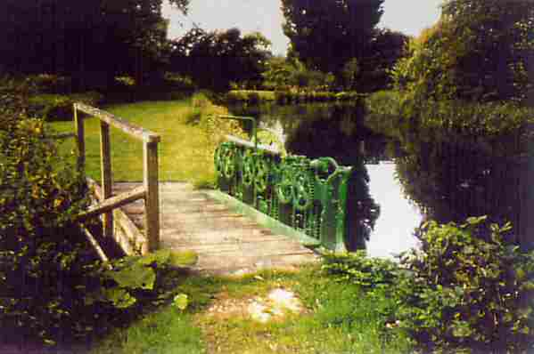
Structure 19C at Littlecote

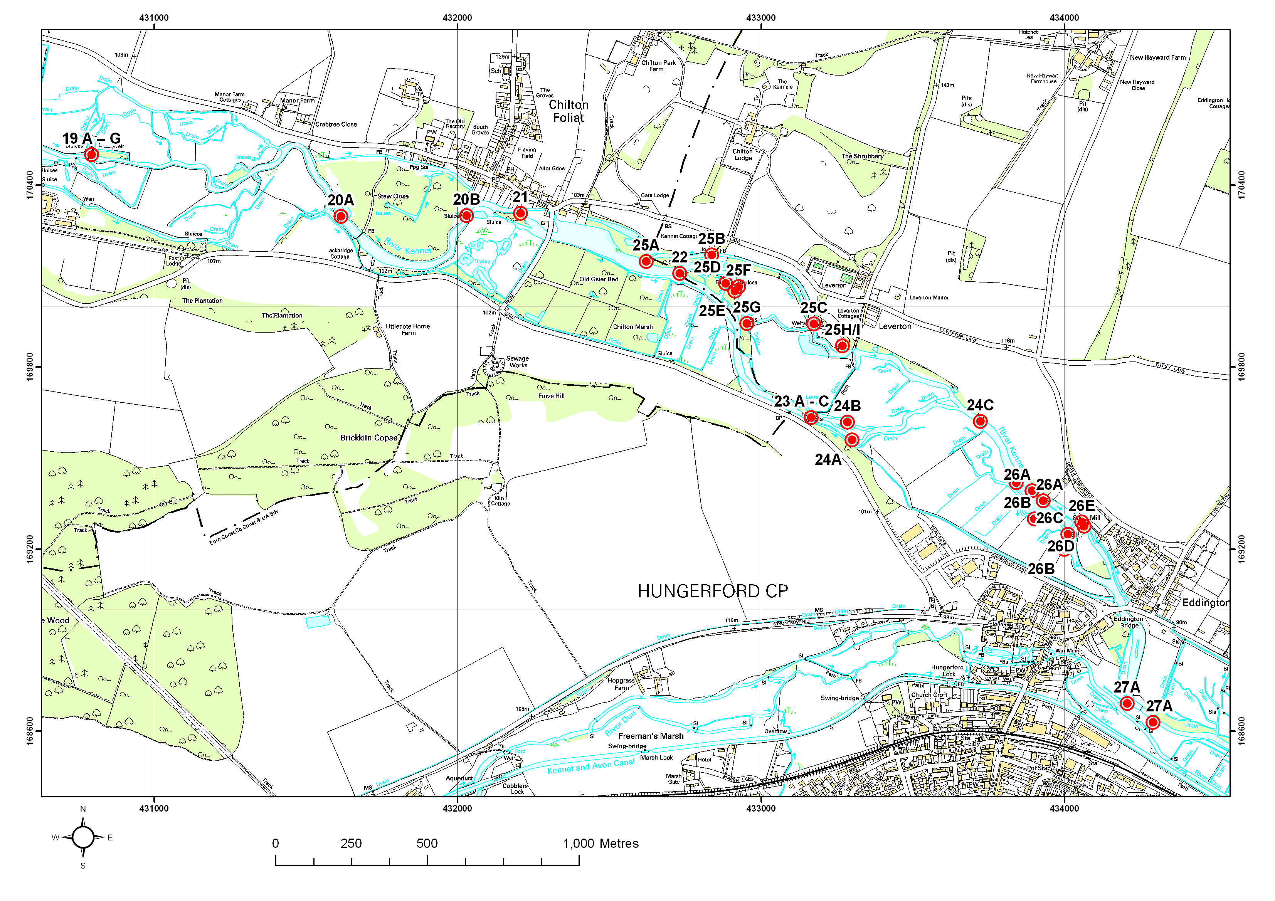
This map is reproduced from Ordnance Survey material with the permission of Ordnance Survey on behalf of the Controller of Her Majesty’s Stationery Office © Crown copyright. Unauthorised reproduction infringes Crown copyright and may lead to prosecution.
This map is reproduced from Ordnance Survey material with the permission of Ordnance Survey on behalf of the Controller of Her Majesty’s Stationery Office © Crown copyright. Unauthorised reproduction infringes Crown copyright and may lead to prosecution.
Figure 6.4 Structures 19 to 27 on the River Kennet

Structure ID 20B, and 21
Priority | Priority
Description | A series of structures between SU316703 and Chilton Foliat Mill at SU323704.
Grid reference | SU321704 (20B), SU322703 (21) and SU328702 (22)
1999 WLMP comment | 20B: A series of control structures are present adjacent to the islands above the mill. A small structure with dropboards and adjacent stakes allows water to feed into a small weed collection pond 0.3 m below river level. A makeshift structure of wood and poles prevents weed from leaving the pond. There is a bridge with a single iron hatch, long disused, which controlled water passage down the south side of the island with a drop of approximately 1.5 m from the river to the back channel.  21: Sluice, Chilton Foliat Mill  21A: The mill bypass channel is controlled by a set of five wind-up gates, approximately 1m wide each. Two of these have weed racks. Measurements are: SL: 100.00 mAOD; IL: 98.20 mAOD. The maximum opening of the sluice gates is 99.4 mAOD.  21B: The original mill channel still retains some flow.
2006 Review comment | Chilton Foliat Mill, Structure 21, is a set of side sluices operated by the Littlecote river keeper. Structure 20B is a weed rack at the furthest upstream point from the Mill. This has an associated side sluice which is used to float off cut weed and is shut the rest of the time. Downstream of here is a fixed crest overspill with a single undershot sluice in the centre. This is no longer used and the channel downstream is heavily overgrown. When in use this sluice fed water into a significant channel to the south of the main river. Next there is a set of three undershot sluice gates and two eel traps all of which appear to be operational. The bulk of the river flow goes through this structure. Excess flow goes through the mill, though in low flow conditions this channel is shut down. A further side sluice upstream controls flow onto a channel which joins just upstream of Chilton Foliat bridge.  The channel upstream is overwide, deep and the substrate dominated by silt. In places the banks show signs of previous dredging activity. The impoundment goes as far upstream as an island created during the 1980s, a distance of about 300 m.  There would appear to be scope for sending more flow down the structure downstream of the weed rack to reduce the impounding effect, help draw through the silt, and allow fish passage. Some flow will need to be maintained down to the mill house and associated side structure. The channel downstream of the weed rack may need some enhancement works. It is thought that the landowner would not be interested in making any structural changes.
Actions needed | A feasibility study is required to fully explore possible options for opening the blocked channel downstream of the weed rack, restoration and changing the split in flow. Any changes should consider the potential effect upon the water levels of Chilton Foliat Meadows SSSI (see the WLMP for that site).

Structure ID 22, 23 25B, 25E to H/I
Priority | Priority  Need to consider works on these structures as a whole
Description | Chilton Estate
Grid reference | SU328702 (22), SU332696 (23), SU328702 (25B), SU329701 (25E), to SU332698 (H/I)
1999 WLMP comment | 22: Sluice leading from the Broadwater into the Kennet comprising 5 metal hatches with a footbridge.  23: Three part structure: 23A: This section is fixed and partly derelict, stopping water passing into a side channel. This provides access into a weed pit. 23B: The central sections comprise 6 metal hatches and this is maintained open to allow as fast a flow as possible through the upstream sector to benefit fishery interests. 23C: Controls the water entering the side channel.  25: A number of structures on the Leverton Water Garden, Colt Stream and Pumphouse Stream. The structures around the Broadwater including 22 above are managed to maintain the water level at the base of the three brick steps on the fishing house.  25B: Pumphouse. Formerly housing a turbine there are four hatches each protected with a weed rack. Each is approx 2.5 m wide and they retain a head of approx 3 m. No levels data are available.  25E: A structure comprising of three metal hatches which is used to maintain the level in the Water garden. Each hatch is approximately 70cm wide and there is a head of about 30 cm. The structure is rarely operated being managed to provide a constant level above it but is kept approximately half open in order that silt does not accumulate.  25F: A derelict hatch formerly used to flood the old water meadows.  25G: A derelict structure at the point where the channel turns through 90 degrees. Approximately 60 cm wide. The structure now has a single board in it to back the level up in the channel parallel to the river. At right angles is a grill which leads into the area of the stew ponds.  25H/I: A spring fed pond joined to the stream by two outlet pipes.
2006 Review comment | 22 Chilton Estate side sluice. A fairly large structure on the right bank which to a certain extent controls water levels in the Broadwater. It has a large controlling influence over the flows which go down a channel on the left bank and pass through the pump house sluices. Operated by the river keeper at Chilton Estate, Steve Jones, and is owned by Gerald Ward.  23 Chilton Estate, Hungerford Road. This is a large set of sluices which historically would have been used to raise levels to provide water across the adjacent meadows. They are still operational and are managed by the river keeper, Steve Jones. This set of sluices may have some influence on keeping Chilton Marsh wet. There does not appear to be a major impact on the river upstream of these sluices.  25B Chilton Estate pump house. This structure probably has relatively little impact on the main river though it does create an impoundment upstream of it. There is an overspill weir at the bottom end of this channel which maintains the head and controls flows into the carrier stream which flows down from the ‘Chilton Estate fish ponds’ structure (see below). This is a complicated system which needs to be approached in conjunction with all the Chilton estate structures.  25E to I - Chilton Estate fish ponds. There are two sets of sluices here, both operational and managed by the river keeper. The larger set controls flows down the larger channel to the south, which then meet up with flows from ‘Chilton Estate side sluice’ above. The smaller set control flows down a carrier stream, also called the Colt Stream, which eventually meets up with ‘Chilton Estate pump house’ above. The main sluices also control water levels for the adjacent fish ponds. As outlined above, this is a complicated system in which individual structures cannot be taken in isolation.  There are numerous structures on the river here which affect the flow and fish passage. The aim is to achieve a satisfactory operating agreement that maximises the benefit of one of the channels and allows fish passage. One solution may be to starve the pump house channel of water by diverting more flow down through Structure 22 and through the fish pond structures. The pump house channel is little fished and is heavily silted so it is not likely to be missed as a resource by the estate.
Actions needed | A feasibility study is required to maximise the potential of the river through this estate. This is likely to include agreeing the best operating methodology to try and establish at least one chalk stream channel in favourable condition. This channel should have unrestricted fish access.

Structure ID 26A-E
Priority | Priority
Description | Set of structures at Eddington Mill
Grid reference | SU338698, SU339694, SU339694 (A), SU339693, SU340692 (B), and SU341694 (C)
1999 WLMP comment | Immediately above Eddington, is a lake which is fed (26A) from the river Kennet. The lake is non-SSSI and is stocked with fish. The Kennet flows one side of the lake and a back channel (SSSI), which receives water from the lake (26B), flows on the other. There is also another outfall to the stream near to the Kennet (26B). The back stream is part spring fed and partly flows from the weed rack at 24C and joins the Kennet downstream of structure 26C. Immediately below the lake is a set of sluice structures (26C) where the Kennet bypasses the Mill. Water passes under the mill (26D) and rejoins the Kennet via a stream. Water also overspills (26E) into the Mill “Waste Stream” which flows past Eddington Bridge and onto Eddington Marsh before joining the main Kennet at SU345685. The owner has the right to manage the main river sluice structure to maintain the level upstream. These are maintained on a day-to-day basis by the Town and Manor of Hungerford. The level above the Mill must be kept in very close limits as a high level threatens the Mill and a low level starves the lake. Levels in the other watercourses are not controlled.  26A: There are three offtake from the River Kennet, the first of which takes the bulk of the flow into the lake. The others which are approximately 1.5 m wide are open to the river. There is provision for boards in these structures.  26B: One outflow from the lake is protected by a grill and comprises a hatch with provision for boards. It is controlled by Lord Rootes to put enough water down the back stream to make it fishable. The downstream outfall to the back stream comprises a hatch which may be pulled, with a grill on the downstream side.  26C: The main structure at Eddington comprises an overspill with three hatches. The overspill has 25 cm boards across it. The right hand overspill functioned as an eel trap. Each hatch is approximately 1.5m wide and the overspill is 2 m wide. Sluice, 96.25 mAOD.  26D: Under the mill are two turbines which are protected by screens. These are operated on a regular basis in order that they are kept clean.  26E: On the left side of the mill is an old sluice which controls the water to the “Waste Stream”. This is a metal hatch approximately 0.7 m wide. Lord Rootes has exclusive fishing rights over the Waste Stream as far downstream as Eddington Bridge and has the right to manage the flow accordingly. There are potential problems with this steam as the stream is now backed with new houses on the northern side. The bank supporting the overspill is owned by the Town and manor and the footpath belongs to Berkshire County Council. This bank must be maintained or the overspill channel will collapse into the river.
2006 Review comment | This is a major set of structures which have a significant effect on levels, flows and habitat quality upstream. The main set of sluices, which have an eel trap built in, historically raised levels to supply water for the mill. These are operated by the Hungerford Town & Manor river keeper, Rob Starr. The mill sluices are no longer operational, in very poor condition, and there seems to be some doubt over the actual ownership of some or all of these structures. A side sluice upstream controls flows down a small bypass channel which rejoins the main river at the tail of the hatch pool. The main sluices (fair condition) now mainly control water levels so that the adjacent lake can be maintained as a fishery via a number of small side sluices. The stream that crosses structure 26B is very good fish habitat and receives the discharge from the lake. Rob Starr manages structure 26C but the ones under the mill itself (poor condition) are owned by the widow of the previous owner. Structure 26C marks the upstream boundary of the river reach managed by the river keeper of Hungerford Town Manor.  Lord Rootes owns the lake and south side of the land. The lake receives water from the river and, to prevent further siltation, the landowner proposes to reduce the number of inlets to 1 and to let a reed area develop in the north west corner. These changes should mean that more water is kept in the river channel.
Actions required | A feasibility study is required to investigate the management and condition of the mill structure determine management responsibilities and get a management agreement in place. Options to consider include sending more water down the channel which flows south of the lakes, this would help increase the gradient and remove the impounding effect of the main mill. It may also be an option to replace the side structure at the mill to allow more flow and fish passage. It is critical to maintain flow down the ‘waste stream’ as this is a major feed for Eddington Meadows which is a component part of the Kennet and Lambourn Floodplain SAC and SSSI

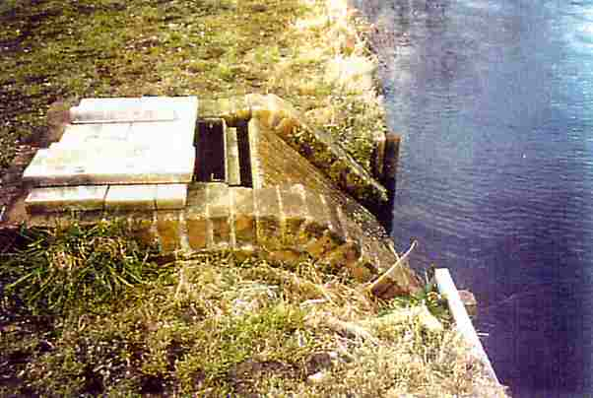
Structure 26B: outflow from the Eddington Lake to the back channel

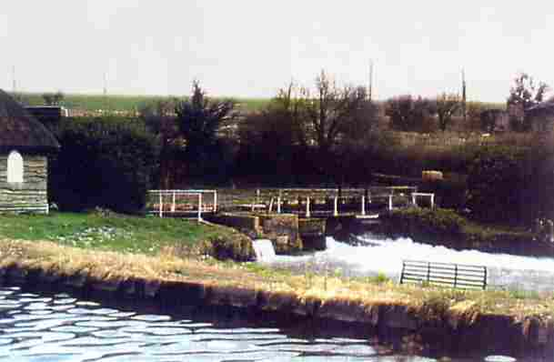
Structure 26C: the main structure at Eddington Mill

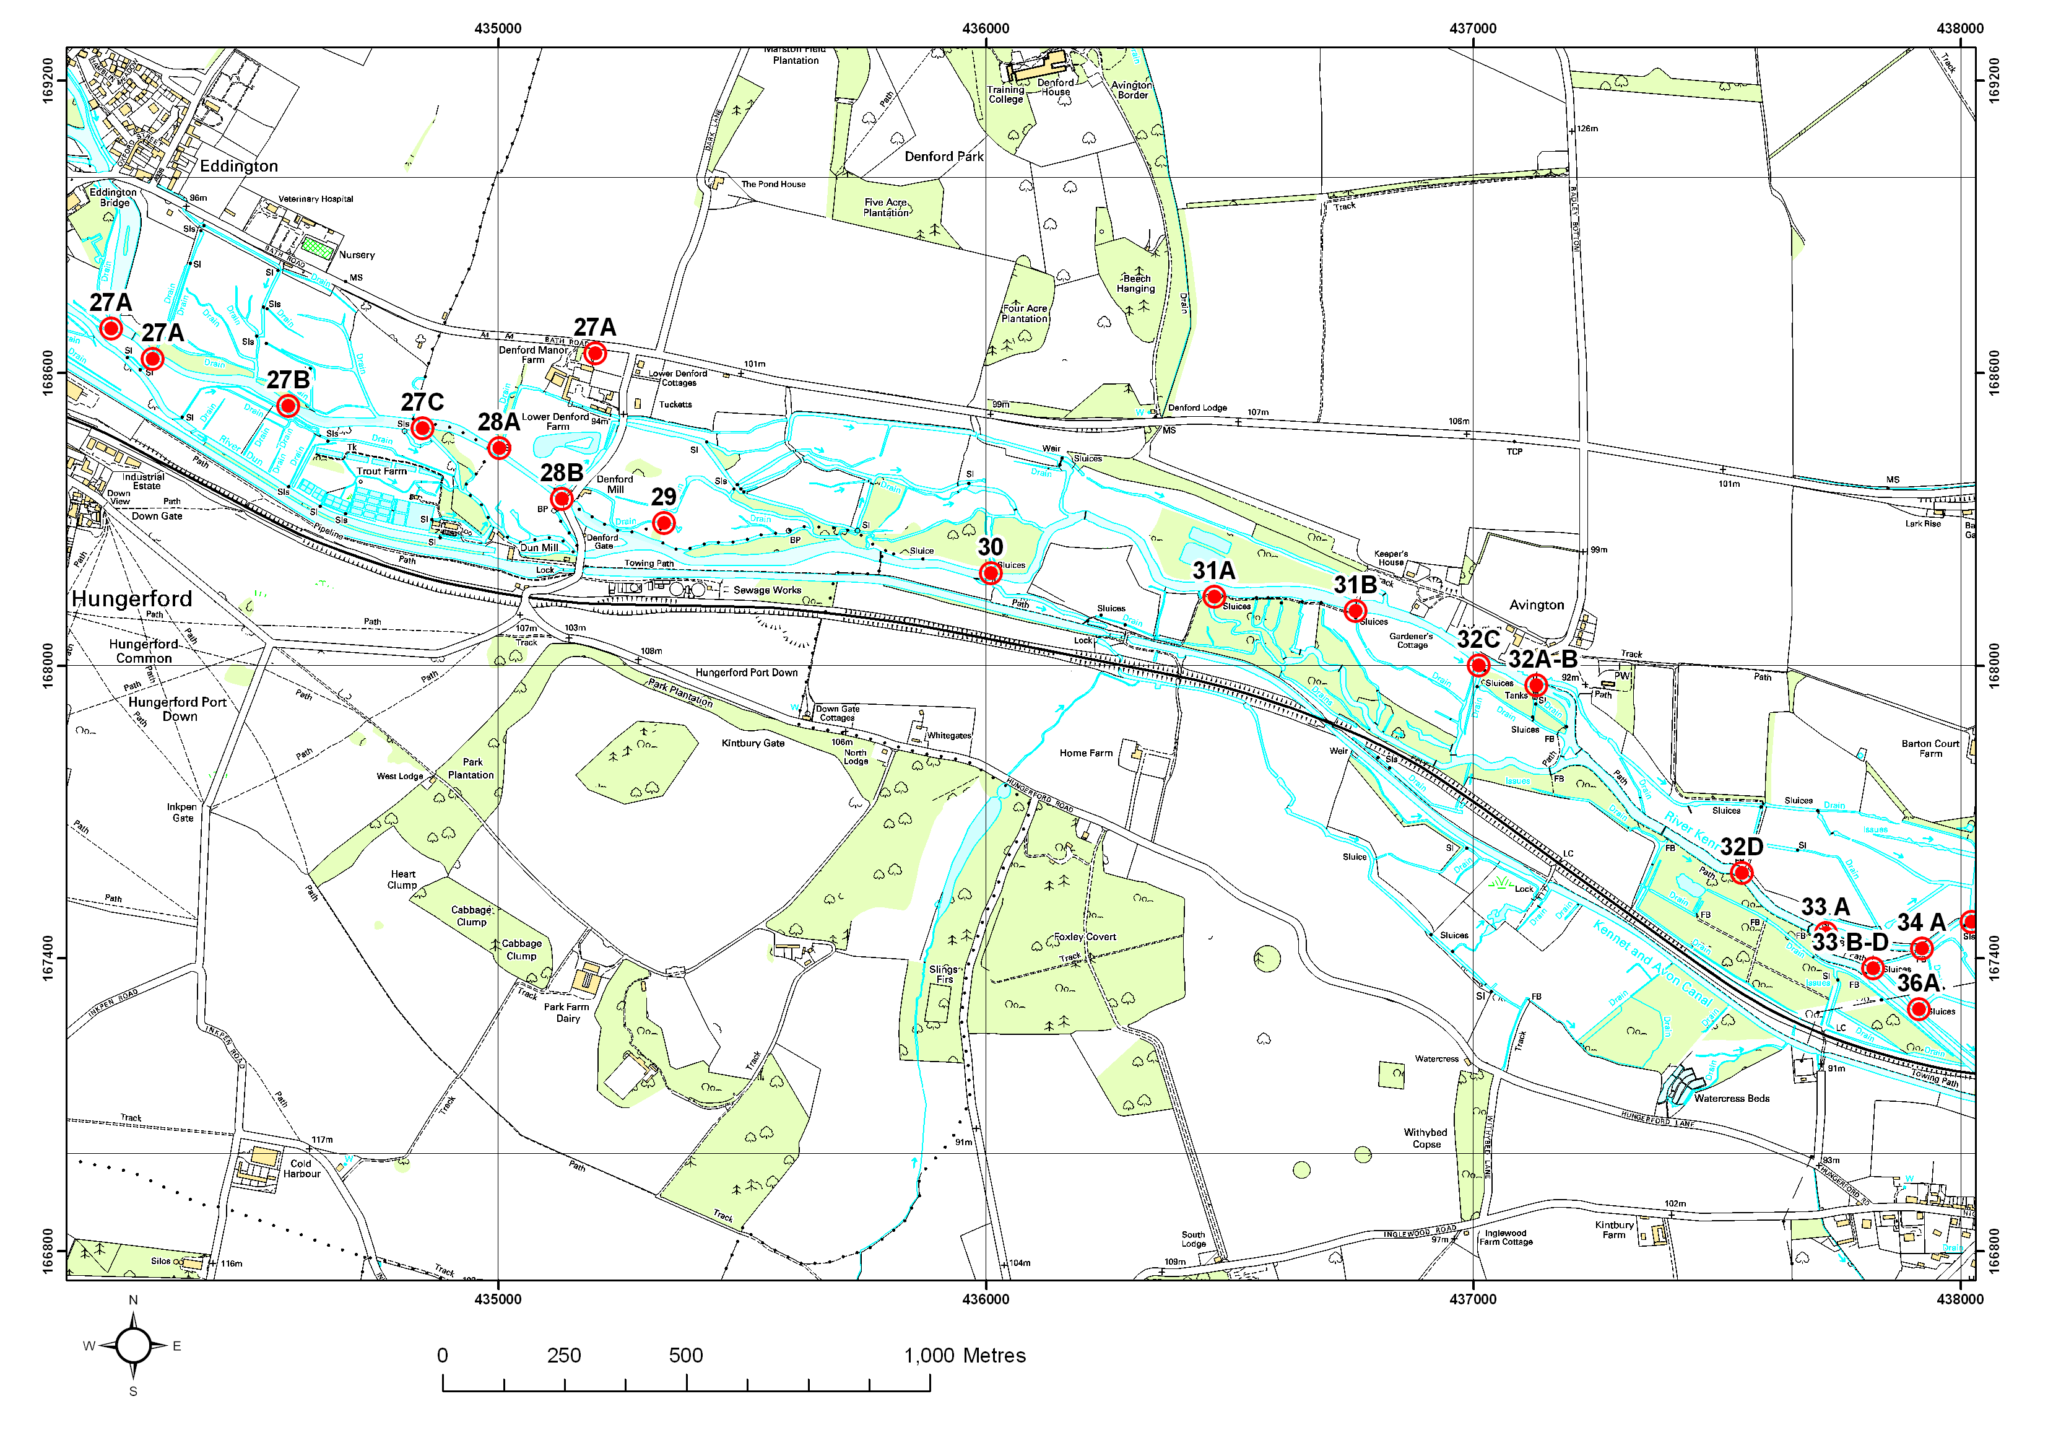
This map is reproduced from Ordnance Survey material with the permission of Ordnance Survey on behalf of the Controller of Her Majesty’s Stationery Office © Crown copyright. Unauthorised reproduction infringes Crown copyright and may lead to prosecution.
Figure 6.5 Structures 27 to 34 on the River Kennet

Structure ID 27C
Priority | Low priority
Description | Structures and inflows between Eddington Bridge and Brackets Hatches
Grid reference | SU347685
1999 WLMP comment | Bracket Hatches marks the point where the River Kennet splits. The water passes over the hatch and goes past Dun Mill in what was the original channel. The main channel of the Kennet now goes through Denford Mill. Both channels are within the SSSI and there is an approximate split of 50% of the flow. Upstream of the structure, which is a 1.5 m spillway and a hatch approximately 0.7 m wide with provision for boards, is a weed rack. A discharge from the weed rack above the Bracket Hatch feeds a weed pond which empties into the river below the Bracket hatch. Bracket Hatch is controlled in parallel with the structure at Denford Mill to maintain levels in the main Kennet. In periods of high flow, levels in the Dun may rise and on these occasions Bracket hatch is closed to protect Dun Mill. Immediately below the structure, the Black Ditch enters the back channel running from the Dun. The flow in the ditch is controlled by the Town and Manor via a sluice where it leaves the Dun. The discharge from the Berkshire Trout Farm also enters into the stretch.
2006 Review comment | There are two sets of sluices controlling flows down the main river and the side channel which leads down past Hungerford Fish Farm and joins the Dun and Kennet below Dun Mill. Bracket Hatches control the levels upstream of Denford Mill and thus the flows down two side channels to the north which feed the Denford Fishery. There is a local dispute between the owners of Denford Fishery, Hungerford Town and the owners of Denford Mill over distribution of flows as the Denford Fishery is almost totally dependant upon water levels here for their fishery. There is a big weed rack. The structure seems to be managed in such a way that minimises any impact on the river.
Actions needed | Management agreement to minimise any impact on the river and conflict over the flow split.

Structure ID 28B
Priority | Low priority
Description | Denford Mill. Sluice
Grid reference | SU352684
1999 WLMP comment | The main Kennet continues from Bracket Hatch where it is then largely drawn off to supply the Denford Fishery. It is understood that the offtake (28A), a small structure, is at SU350684 which formerly supplied a small carrier. A small amount of water passes under the mill to the mill pool and was originally the stream which turned the mill wheel. It passes via two sluice gates (28B) which can open to a maximum opening of 93.7 mAOD. Control of the level is achieved by co-ordination (undescribed) between the settings at Denford Mill and Bracket Hatch. If too much water is taken at this point then the fishery of the Town and Manor above suffers reduced water levels.
2006 Review comment | There is no direct knowledge of this structure as it is difficult to access, and the management regime is unknown. It controls flows down a side stream which flows north towards the A4 road and which is one of the main feeders for the Denford Fishery (see description of Structure 27C). This is the focus of another dispute over flow split (see Section 14).
Actions needed | Operating agreement to minimise any impact on the river and conflict over the flow split.

Structure ID 30
Priority | Priority
Description | Avington Number 1
Grid reference | SU361682
1999 WLMP comment | Sluice and footbridge, 92.3 mAOD. Three metal hatches managed to maintain levels approximately 35 cm below bank top. Changes in the operation of these structures can cause a rise of 60 cm at Brackets Hatch. There are three wooden hatches each approximately 1m wide retaining a head of approximately 60 cm.
2006 Review comment | Structure 30 is termed ‘no 1’ as it is next to fishing platform 1. This set of sluices is operated by the river keeper, David Culley, at Avington Estate. It has an eel trap built in. Historically it would have been used to raise levels to supply the carriers going into what is now the Denford Fishery.  The structure is creating a major impoundment upstream, approximately 600 - 700 m long, almost as far as the outfall from Hungerford sewage treatment works. The river is over wide and canalised in this reach with the banks lined with metal revetments downstream of the structure. There is a weed rack where ‘post’ is written on the WLMP map upstream of structure 30; the post marks the boundary between Hungerford Town Manor and Avington Fisheries to the East. There is an informal break in the bank upstream of the weedrack which feeds water into the Denford Fishery. As this has been in existence for at least 20 years the owners of Denford may feel they have now an established right to this volume of water. There is therefore a need to investigate impact to Denford before any works at Avington No.1 which may cut off flow to the Wilsons’ land.  It is necessary to perform an experimental lowering of the structure to determine the impacts upon water levels, the length of affected reach upstream and to assess the degree of narrowing required. Upstream of the structure there is a distributary (on the right hand side looking upstream) which would lose flow if the structure setting was changed, as the head of water would be dropped. Therefore it is necessary to narrow the river to ensure the tributary still receives water.
Actions needed | A feasibility study is required to examine the effects of proposed changes in management of the structure on the upstream reach, and the need for river restoration. In addition the impact to adjacent landowners should also be investigated.
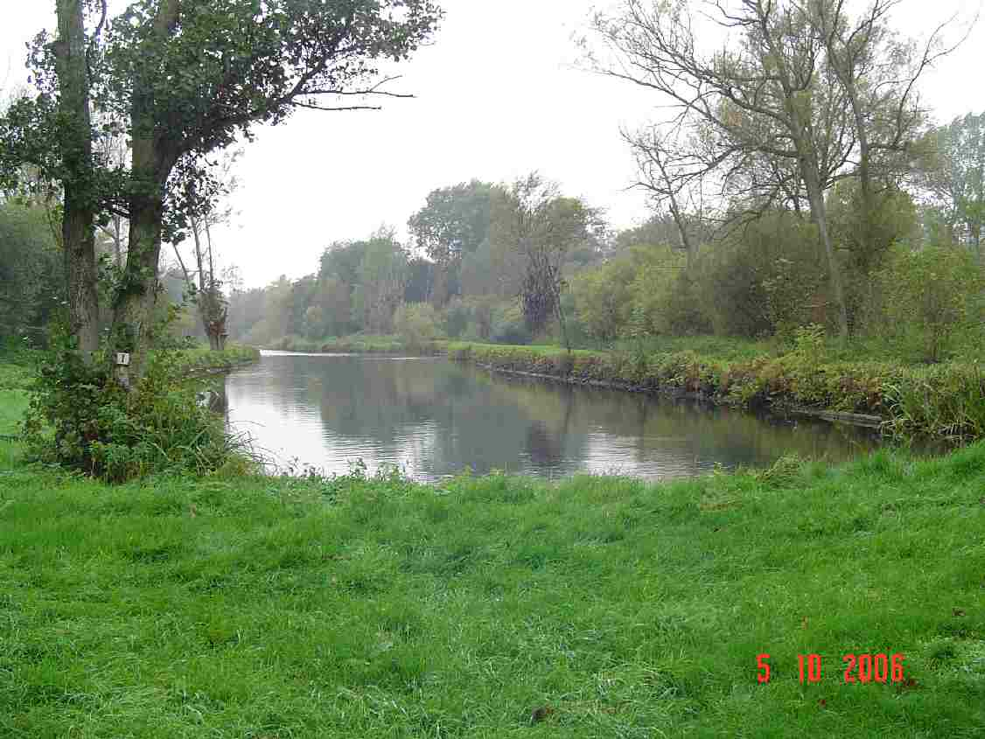
The Kennet at Avington
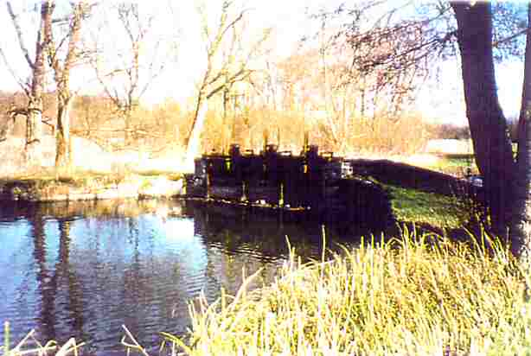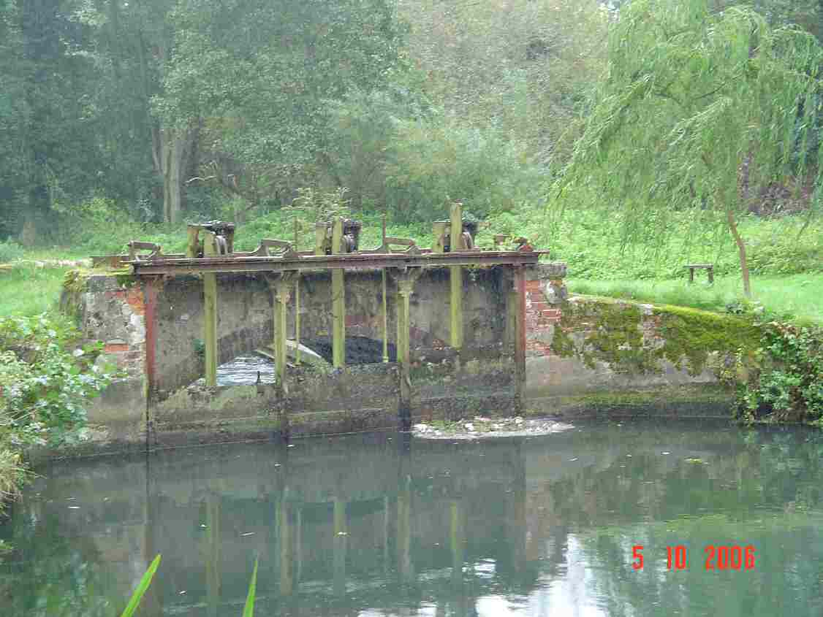
Structure 30: hatches downstream of Denford (above: 1999, bottom: 2006)

Structure ID 31A and B
Priority | Priority
Description | Avington Fishing Hut: set of off-takes from the main Kennet and a sluice under a road bridge.
Grid reference | SU366682 – SU368682
1999 WLMP comment | 31A: A series of 6 single metal hatches which are operated to maintain a flow of water through side channels for fishing. The non-SSSI side channels all flow into a SSSI back channel.  31B: Structure underneath the road bridge. Comprising 9 metal hatches currently being renovated. Each hatch is approximately 1 m wide and the maximum opening of the structure is 92.4 mAOD.
2006 Review comment | Structures 31b and 32A and historic dredging cause a long impounded section. Easiest option may be to get water to flow down the SSSI tributary to the south rather than improve this section. If this was done by opening up a free flowing channel then fish passage would not be an issue. Works will be required to the back channel as in some places it is extremely overgrown. Feasibility investigations have already been undertaken for Avington Estate; one of the options was to divert more water down this channel. Obviously some flow will need to be maintained down through structures 31B and 32A but as they can be tightly controlled maintaining a head of water for landscaping purposes should not be a problem. Some of the smaller channels that feed off the main channel upstream of 31B provide nice habitat and the aim should be to maintain some flow down these if possible.
Actions needed | Review of the existing feasibility study into the options to change the current flow split to encourage more water to flow down the back SSSI channel, river restoration and management agreement.

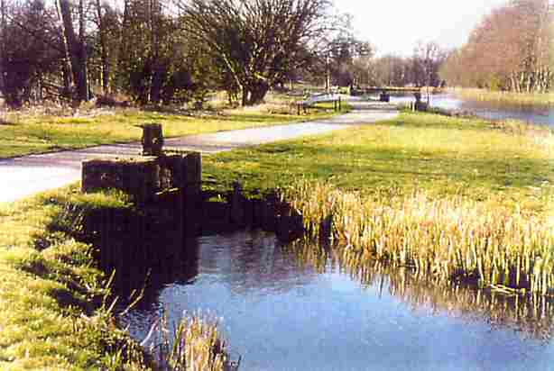
Structure 31A offtakes from the Kennet to the back channel (1999)

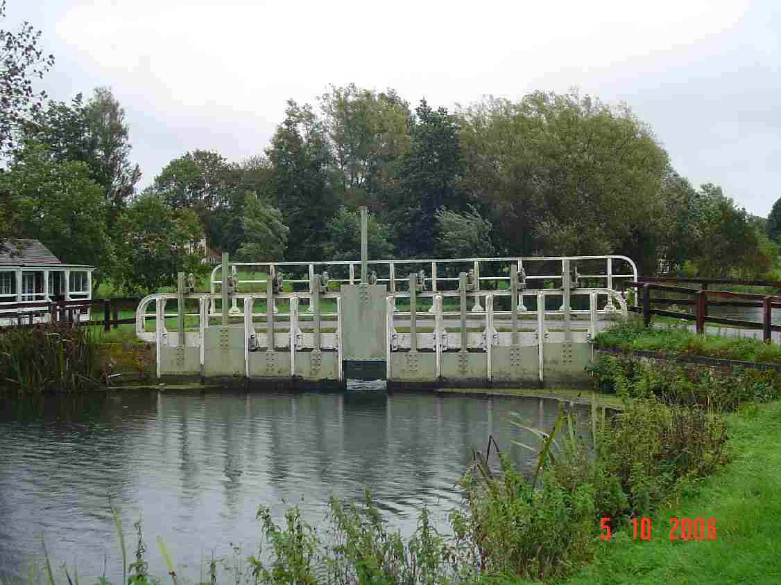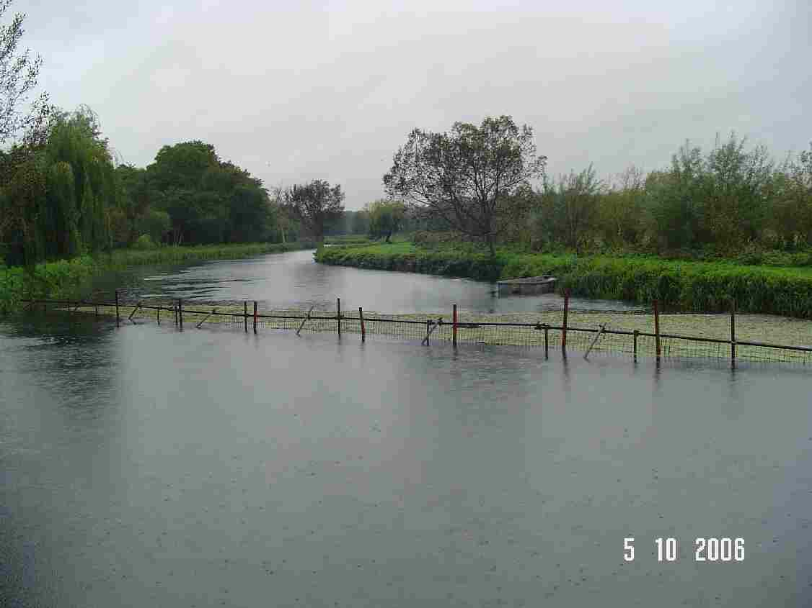
Left: Structure 31B beneath the road bridge at Avington and right: the new weed screen in front of Structure 31B (2006)

Structure ID 32A-B
Priority | Low Priority
Description | Main structures at Avington
Grid reference | SU372679
1999 WLMP comment | 32A: Sluice. A set of 8 metal hatches in three banks, 2, 2 and 4. Each hatch is approximately 1 m wide and there as a head of approximately 1 m. The structure has recently been renovated to its original condition as it was being undermined.  32B: Immediately above the sluices is an offtake to the stew ponds which has provision for boards. The outflow from this joins the back SSSI channel.
2006 Review comment | This is a large set of undershot sluices which are operated by the river keeper. These are of wooden construction and are not in good condition. The head is used to control levels into some adjacent brick built fish ponds which are still used by the Estate. Flow from here rejoins the low level channel fed by the side sluices above 31B. Downstream of 32 the river divides with some flow being diverted across a number of water meadow streams to the south-east of the Estate buildings. These re-join the main river again at Barton Court. During a field visit, it was not possible to get to the site where the tributary joins the main channel and view the structure. The current aim is to remove this structure, but whether this would be necessary following any changes to Structure 31A would need to be determined.
Action | If we are successful in using the SSSI side channel (fed from structure 31A), as the main SSSI channel then the operation of these structures become important in maintaining a head in the canalised reach. Operating agreement would need to be produced in conjunction with the changes upstream.

Structure ID 32D
Priority | Priority
Description | Weed rack upstream of Barton Court
Grid reference | SU376674
1999 WLMP comment | An iron weed rack and footbridge owned and managed by the Hungerford Estate.
2006 Review comment | This is a major obstruction that has a significant impounding effect on the river upstream, especially when blocked with weed. . It has a major impact on fish migration and should be removed or bypassed.
Action needed | Remove or alter structure and assess degree of upstream restoration that would be required.
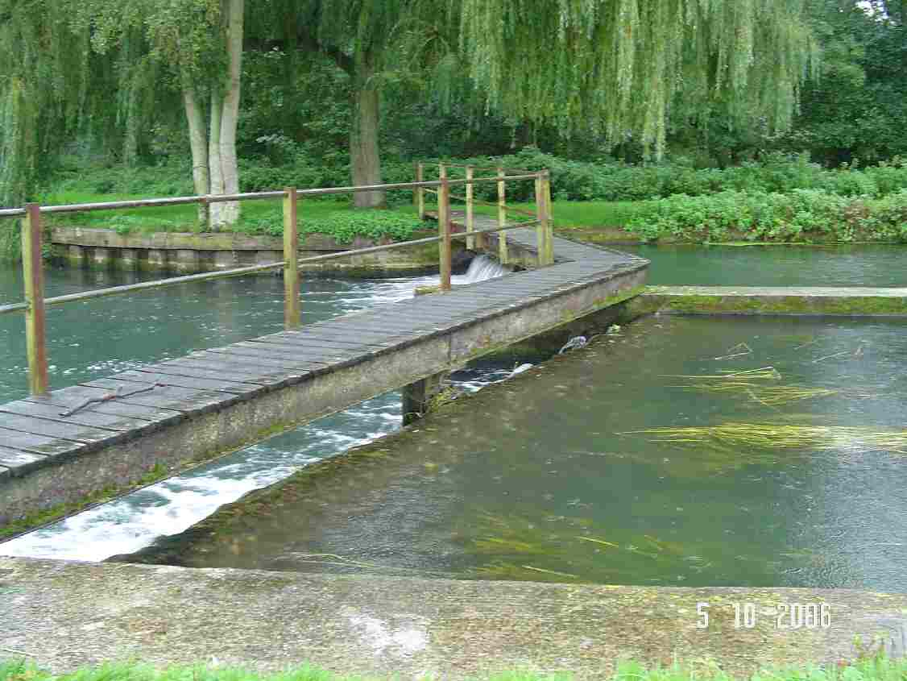
Structure 32D weed rack

Structure ID 33A
Priority | Priority
Description | Small sluice splitting flow between the main Kennet and channel feeding the canal and Kintbury water meadow.
Grid reference | SU376674
1999 WLMP comment | A small sluice allows for the divide of water between the main Kennet (Upper Park Stream) and the set of structures which feed the canal and the Kintbury water meadows. The sluice comprises two hatches each approximately 0.9 m wide which have a maximum opening of 90.35 mAOD. One is owned by Hungerford Park Estate and one by the Hills Group but both are operated by the lessee for Hills, Mr Bailey. They have not been touched for the last 3-4 years and Mr Bailey believed that it would take a substantial flood before they will be altered again.
2006 Review comment | The structure is derelict, impounds the river upstream and restricts fish movement. Thus it should be removed.
Actions needed | Remove the structure

Structure ID 33B-D
Priority | Low priority
Description | Sherman’s Hatches: a series of structures between Hungerford Park Estate and Barton Court
Grid reference | SU376674
1999 WLMP comment | 33B: Sherman’s Hatches. A bank of 6 metal hatches, each approximately 1 m wide controlling the flow of water from the Kennet to the canal. The gradient between the two is very shallow. In times of high flow the hatches are opened to release water to the canal. In low flows, water from the canal may feed into the river and the hatches are then shut down to prevent this occurring. Three are owned by the Hungerford Park Estate and three by the Hills Group. Benham Estate has reserved the right to operate the pair nearest its property, the Hungerford Park Estate can operate a pair and Hills can operate a pair. In practice it is Mr Bailey who operates the structures in discussion with British Waterways. This structure originally provided the head for the Kintbury Mill via the canal and currently provides the major water input into the canal.  33C: Two wooden hatches, each approximately 1m wide which take water from the main Kennet and feed the Willow Stream (part of the SSSI). These are operated by Mr Bailey and owned by Hills.  33D: A single, newly renovated wooden hatch in brickwork which feeds Herons Delight (SSSI). This is managed by Mr Bailey.
2006 Review comment | Sherman’s Hatches controls the flow between the river and the Kennet & Avon Canal, and is operated by British Waterways and/or the tenant at Barton Court (Bob Bailey). It is also partly owned by Avington Estate who has the north bank of the river at this location. There are also three other structures feeding the main river downstream of the weed rack and two of the carrier streams that have an impact on flows and levels at Sherman’s, so this structure cannot be taken in isolation.  The current management prevents the mixing of canal and river water, and protects against poor quality water entering the river.
Actions needed | Consider changes to the operation of the structures to reduce input of flow to the canal in the winter months.

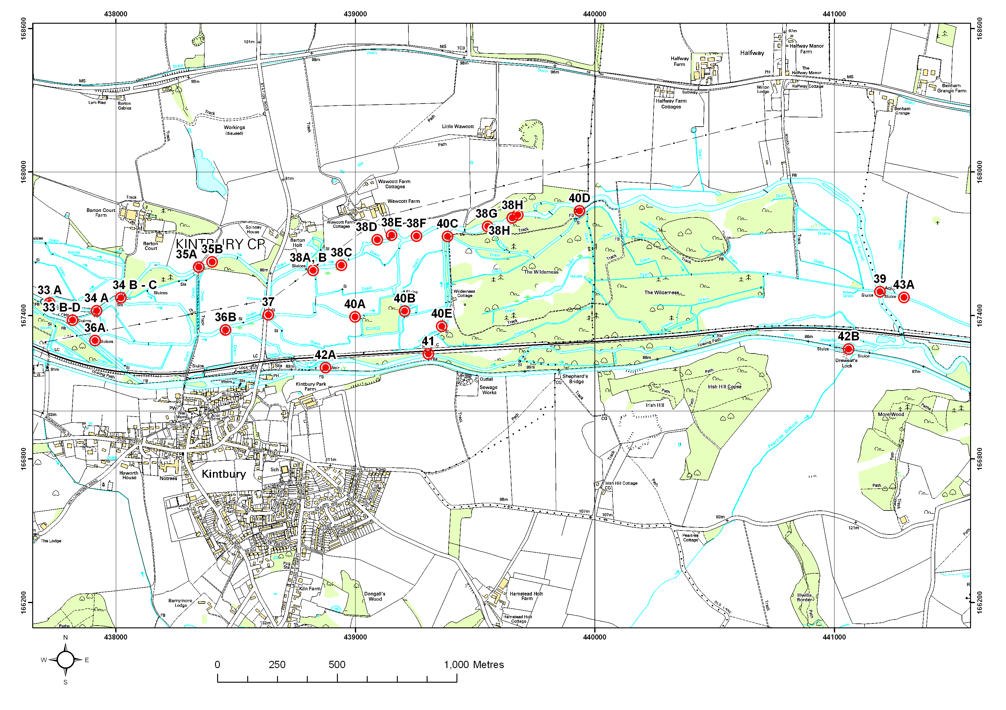
This map is reproduced from Ordnance Survey material with the permission of Ordnance Survey on behalf of the Controller of Her Majesty’s Stationery Office © Crown copyright. Unauthorised reproduction infringes Crown copyright and may lead to prosecution.
Figure 6.6 Structures 34 to 43 on the River Kennet

Structure ID 35A
Priority | No Action Required
Description | Structures below Barton Court
Grid reference | SU384676
1999 WLMP comment | Bridge with sluice and weir. One half of the road bridge has a sluice and the other half has a weir. Maximum opening of the sluice is 89.92 mAOD and the height of the sill of the weir averages 89.4 mAOD. Even without the structures there is a constriction in the channel at this point. The head above the structure is approximately 1 m. The structure controls water in the over-wide and canalised section upstream.
2006 Review comment | This structure has been recently removed/modified so that it no longer poses any problems.
Actions needed | None

Structure ID 36B
Priority | Low Priority
Description | Kintbury Water Meadows
Grid reference | SU379674
1999 WLMP comment | Structure on the Middle Stream controlling the flow into Gunters and thus into the Dundas. This structure is owned by Hills and leased to Mr Bailey. He has reached agreement with the Benham Estate that their water keeper can manage the structure according to his wishes, providing that there is no deterioration in the fishery upstream. No levels data are available.
2006 Review comment | Consider possible management issues over flow split to ensure the small channel downstream of the structure does not dry out.
Actions needed | Management agreement

Structure ID 38A-B
Priority | Priority
Description | Barton Holt
Grid reference | SU388675
1999 WLMP comment | Kennet between the Kintbury Road bridge and the aqueduct over the Lamb Stream. The river is perched along the length beyond Board Lane.  38A: Hatch formerly used to take water to a hydraulic ram which pumped up to houses on the Downs. There was also a turbine attached to this. The head held by this structure is approximately 50 cm.  38B: Old two-span bridge with provision for hatches. Now derelict. Formerly used to hold water high to allow it to flood the meadows. In times of high flow the water bypasses the structure. Approximately 1m head. No levels data are available.
2006 Review comment | This is a redundant set of structures owned by Sir Richards Sutton’s Settled Estates and which the Estate is keen to remove. It is a substantial weir across the channel that provides an impoundment to raise head to feed a lake in the adjacent grounds. Consultation is required with the owner of lake at Barton Holt to ensure that it will not dry up, or find an alternative feed to it. If this can be achieved there will be little opposition to its removal.  Immediately downstream of 38A is 38B. This is a set of hatches through which all the flow in this channel passes. It is a blockage to fish migration and cause an impoundment. A bypass channel could be created which passes to the right of these (looking downstream) and then rejoins the channel. Structure 38B (which is of historical interest) can remain and the pipes blocked. Upstream and downstream restoration will be required to restore the chalk stream features.
Actions needed | Remove weir and find alternative feed for the lake via an existing channel that runs parallel to the river. Advanced plans are currently being drawn up.

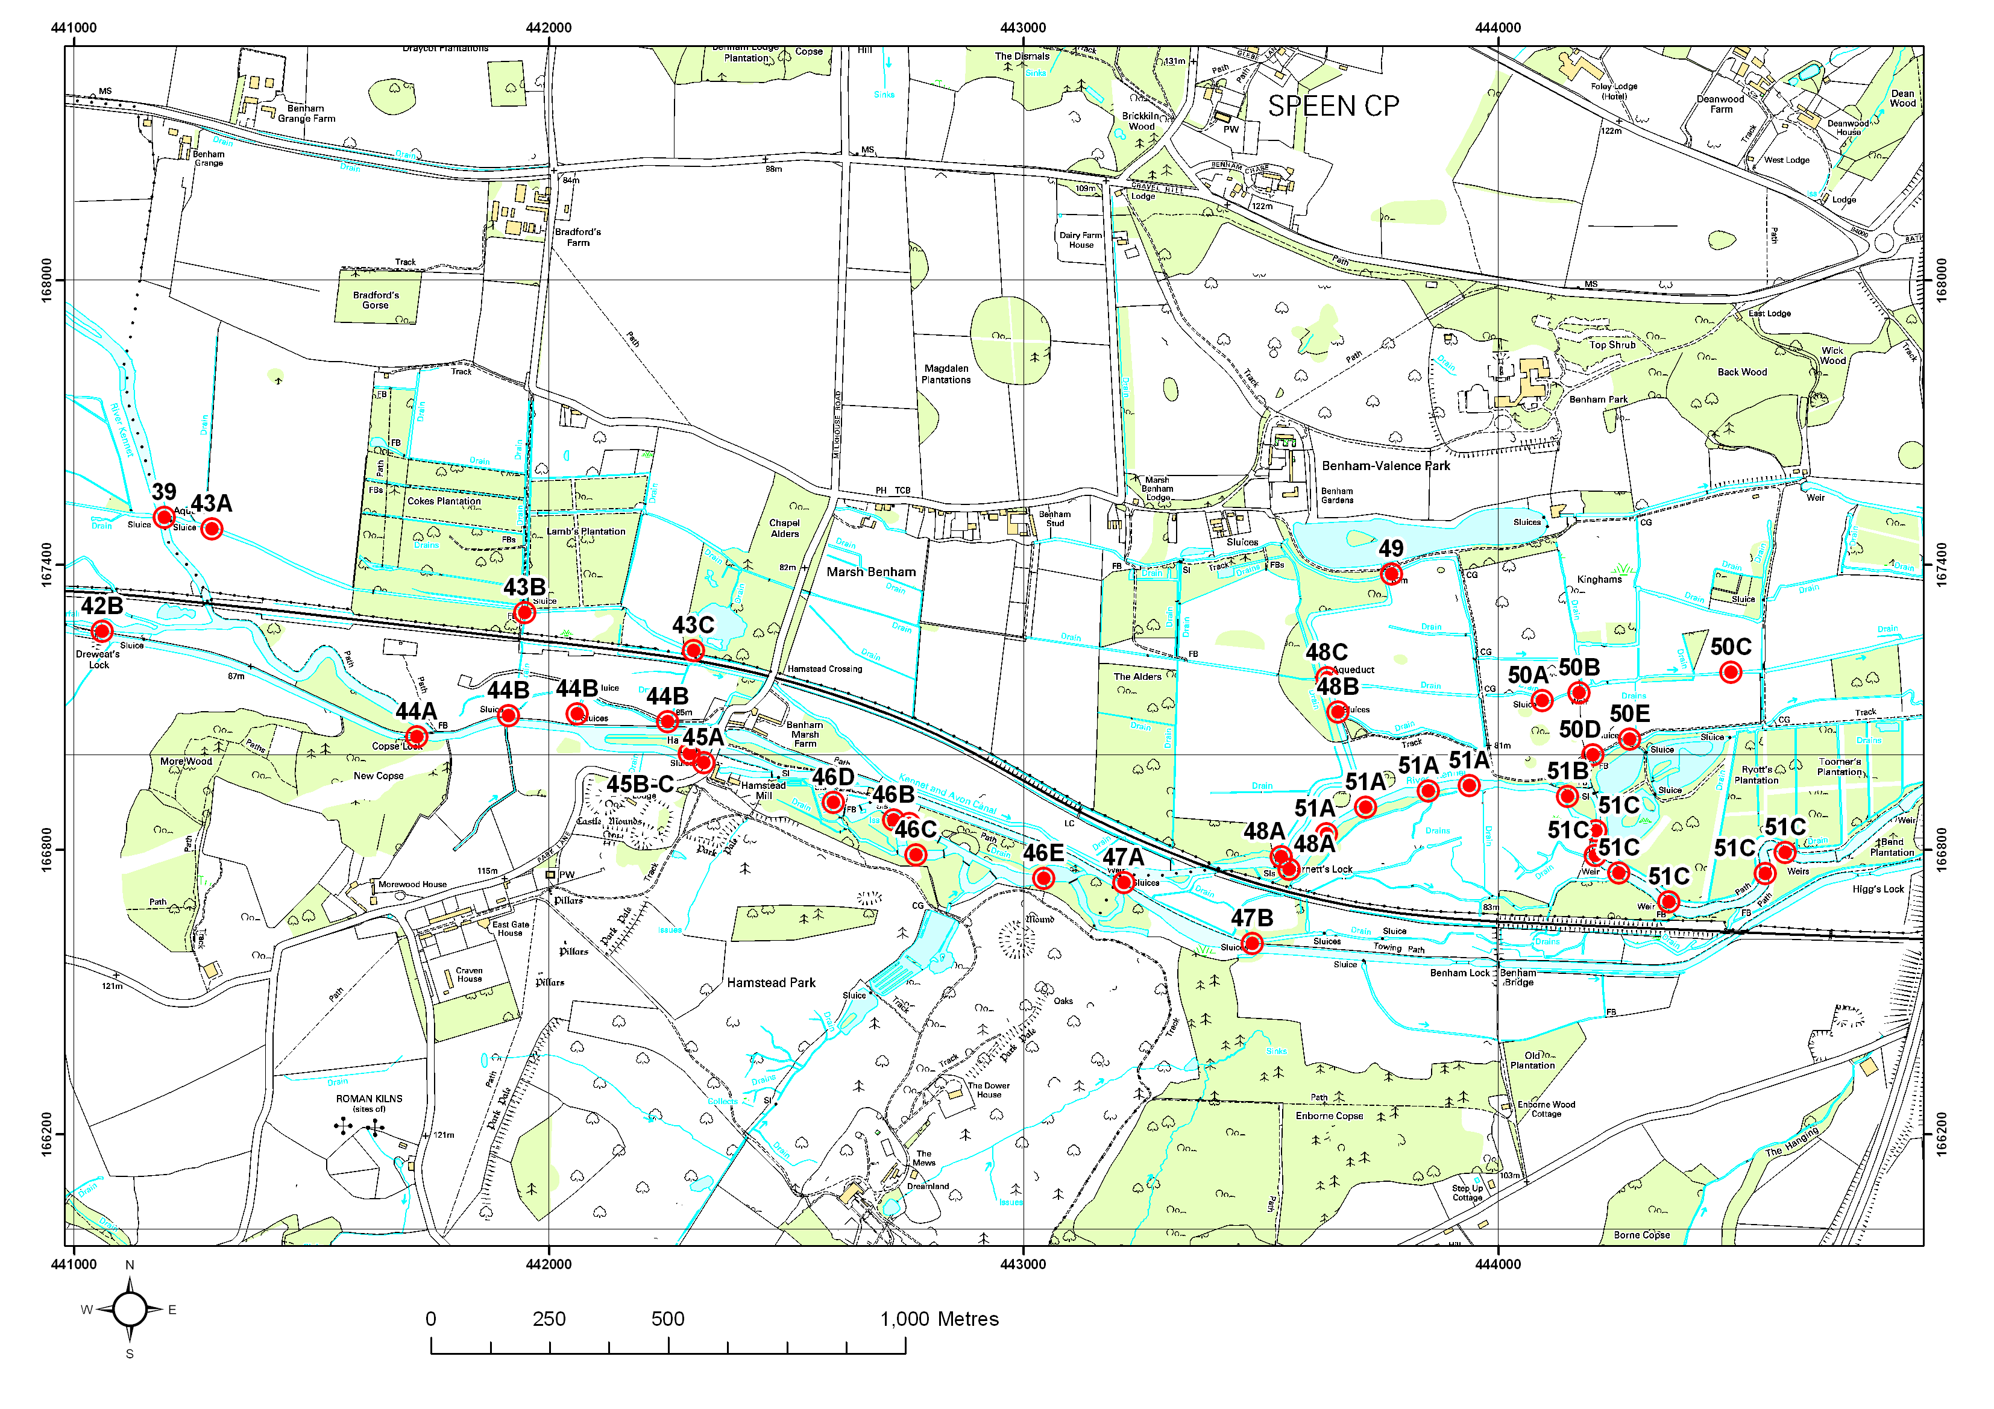
This map is reproduced from Ordnance Survey material with the permission of Ordnance Survey on behalf of the Controller of Her Majesty’s Stationery Office © Crown copyright. Unauthorised reproduction infringes Crown copyright and may lead to prosecution.
Figure 6.7 Structures 43 to 51 on the River Kennet

Structure ID 44 to 47A
Priority | No Actions Required
Description | Copps Lock to Benham Weir
Grid reference | SU419671 (44) to SU432667 (47A)
1999 WLMP comment | n/a
2006 Review comment | It is worth noting in this WLMP Review that there is a feasibility study being undertaken for the area around Copps Lock to identify a solution to the turbidity problems caused by the joining of the canal with the Kennet.
Actions needed | None

Structure ID 45B
Priority | No Actions Required
Description | Hamstead Mill
Grid reference | SU424669
1999 WLMP comment | n/a
2006 Review comment | These sluices control water levels in the Kennet & Avon Canal for navigation. They have been recently refurbished and with the highest-upstream salmon pass built adjacent. It is worth mentioning in the WLMP Review that these sluices may be involved a major canal/river separation proposal.
Actions needed | None

Structure ID 46A-E
Priority | Low Priority
Description | Downstream of Hamstead
Grid reference | SU427668 (A - C), 426669 (D), 431667 (E)
1999 WLMP comment | Fisheries weirs and weed racks downstream of Hamstead
2006 Review comment | Canalised section with locks managed by Geoff Trottman. The reach is managed as an impounded section by the landowner for aesthetic reasons.
Actions needed | Change in management and river restoration

Structure ID 47A
Priority | No Actions Required
Description | Benham Weir
Grid reference | SU432667
1999 WLMP comment | n/a
2006 Review comment | There is a salmon pass here. The structure may also be part of the canal/river separation proposal.
Action needed | None

Structure ID 48A
Priority | Low Priority
Description | Barnetts Hatches and other structures on the Pound Stream
Grid reference | SU436668
1999 WLMP comment | Two sets of structures that on the main Kennet comprising 5 hatches, each 1.5 m wide. The entrance to the Pound Stream is controlled by a set of four hatches each approximately 1 m wide. Benham Estates has an operating protocol agreed with Prof. Norburn at Benham Mill House to maintain the level in Benham Valance Lake and the Back Lodge Ditch (also known as the Mill Stream). These are typical for low flow conditions where a head is required to feed the Pound Stream. In higher flow conditions these hatches may be opened. If the lake requires more water then the Estate will close the hatch nearest to the Pound Stream. In higher flow conditions these hatches may be opened. If the lake requires more water then the Estate will close the hatch nearest to the Pound Stream to push water into that watercourse.
2006 Review comment | This is a double set of sluices. The smaller set controls water flows into a number of carrier streams and into the lake to the north. The large set directs water down the main channel and on into the rest of the Estate. These are owned by the Sutton Estate and operated by the river keeper Gary Allen, and there is a major and ongoing dispute regarding flows into and out of the lake to the north which is privately owned (see Section 14). The sluices seem to be in good condition and are managed as best as they can be to minimise the dispute mentioned above. The channel leading from Structure 48A is the main feed to Benham Lake and also eventually feeds the SAC at Speen and so flow needs to be maintained down this reach. The management of this structure is therefore important and a management agreement is required.
Action needed | Continue existing management. Flows must be maintained down to the lake, and from the lake into stream which feeds the SAC. Further advice has now been given to the owners of Benham Estate on the operation of the relevant structures.

Structure ID 51B
Priority | Low priority
Description | Structures on the main Kennet downstream of Barnett Hatches
Grid reference | Between SU435667 (Barnetts Hatches) and SU452669
1999 WLMP comment | Two weirs, one each side of a small island by the bathing pool. Both have a footbridge over. They are approximately 4.5m wide each and the sill level is 79.58 mAOD and 79.65 mAOD respectively.
2006 Review comment | This is a double set of fixed crest overfalls by the Victorian bathing pools which are in poor condition, and an old undershot sluice to the south, all of which pose a barrier to fish migration. The weirs at the bathing pool cause an impoundment upstream. The river here is wide and deep, and the substrate is dominated by silt.  There is a good opportunity here to restore a more freely flowing channel upstream. The ideal situation would be to remove the structure and get water flowing round the in-channel island, or render the structure inoperable, allowing maximum flow of water through it. The structure is part of the historic interest and value of the Victorian Bathing Pools however, and means that total removal is not a likely option.  An alternative option could be to lower or remove the weir in the side channel to increase the gradient and reduce the impoundment. This will reduce the amount of water flowing into the Victorian bathing pool and as a result this it become siltier. This option will also allow fish passage. The river upstream would need to be restored as appropriate.
Actions needed | A feasibility study is required to assess the options to minimise the impact on the river while retaining the historic interest of the structures and the bathing pool, and the need for river restoration.

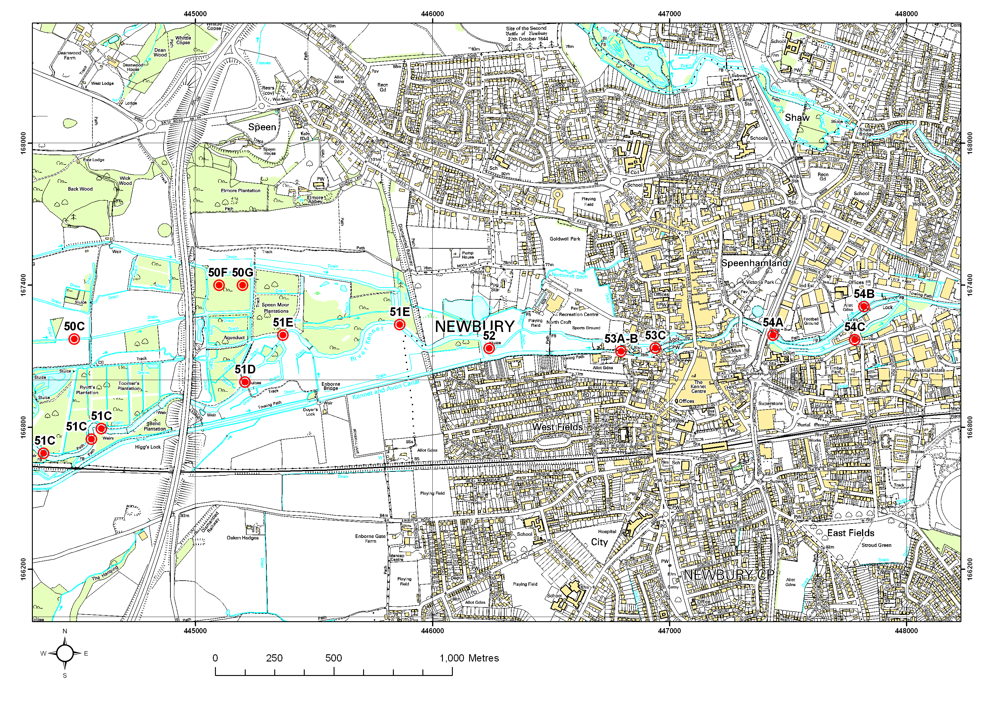
This map is reproduced from Ordnance Survey material with the permission of Ordnance Survey on behalf of the Controller of Her Majesty’s Stationery Office © Crown copyright. Unauthorised reproduction infringes Crown copyright and may lead to prosecution.
Figure 6.8 Structures 51 to 54 on the River Kennet
This map is reproduced from Ordnance Survey material with the permission of Ordnance Survey on behalf of the Controller of Her Majesty’s Stationery Office © Crown copyright. Unauthorised reproduction infringes Crown copyright and may lead to prosecution.
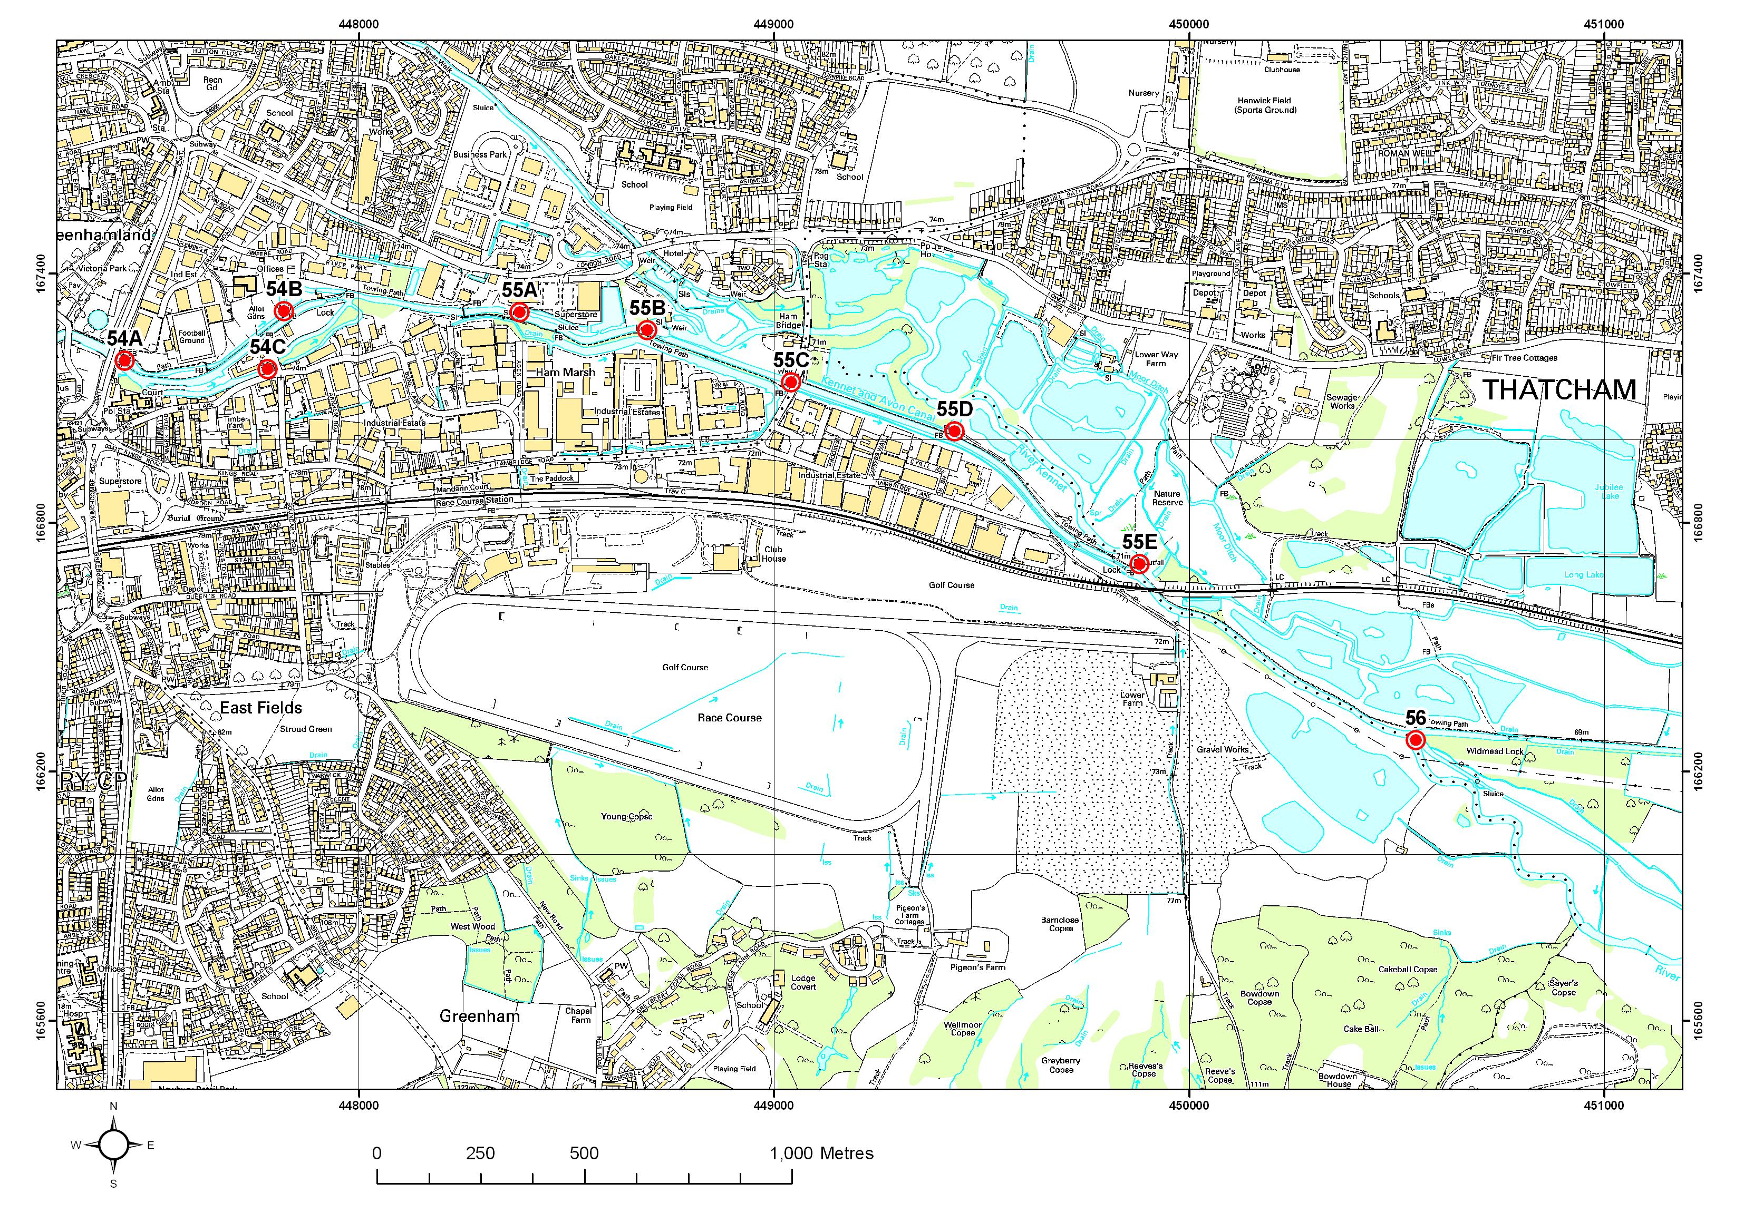
This map is reproduced from Ordnance Survey material with the permission of Ordnance Survey on behalf of the Controller of Her Majesty’s Stationery Office © Crown copyright. Unauthorised reproduction infringes Crown copyright and may lead to prosecution.
Figure 6.9 Structures 54 to 56 on the River Kennet
This map is reproduced from Ordnance Survey material with the permission of Ordnance Survey on behalf of the Controller of Her Majesty’s Stationery Office © Crown copyright. Unauthorised reproduction infringes Crown copyright and may lead to prosecution.
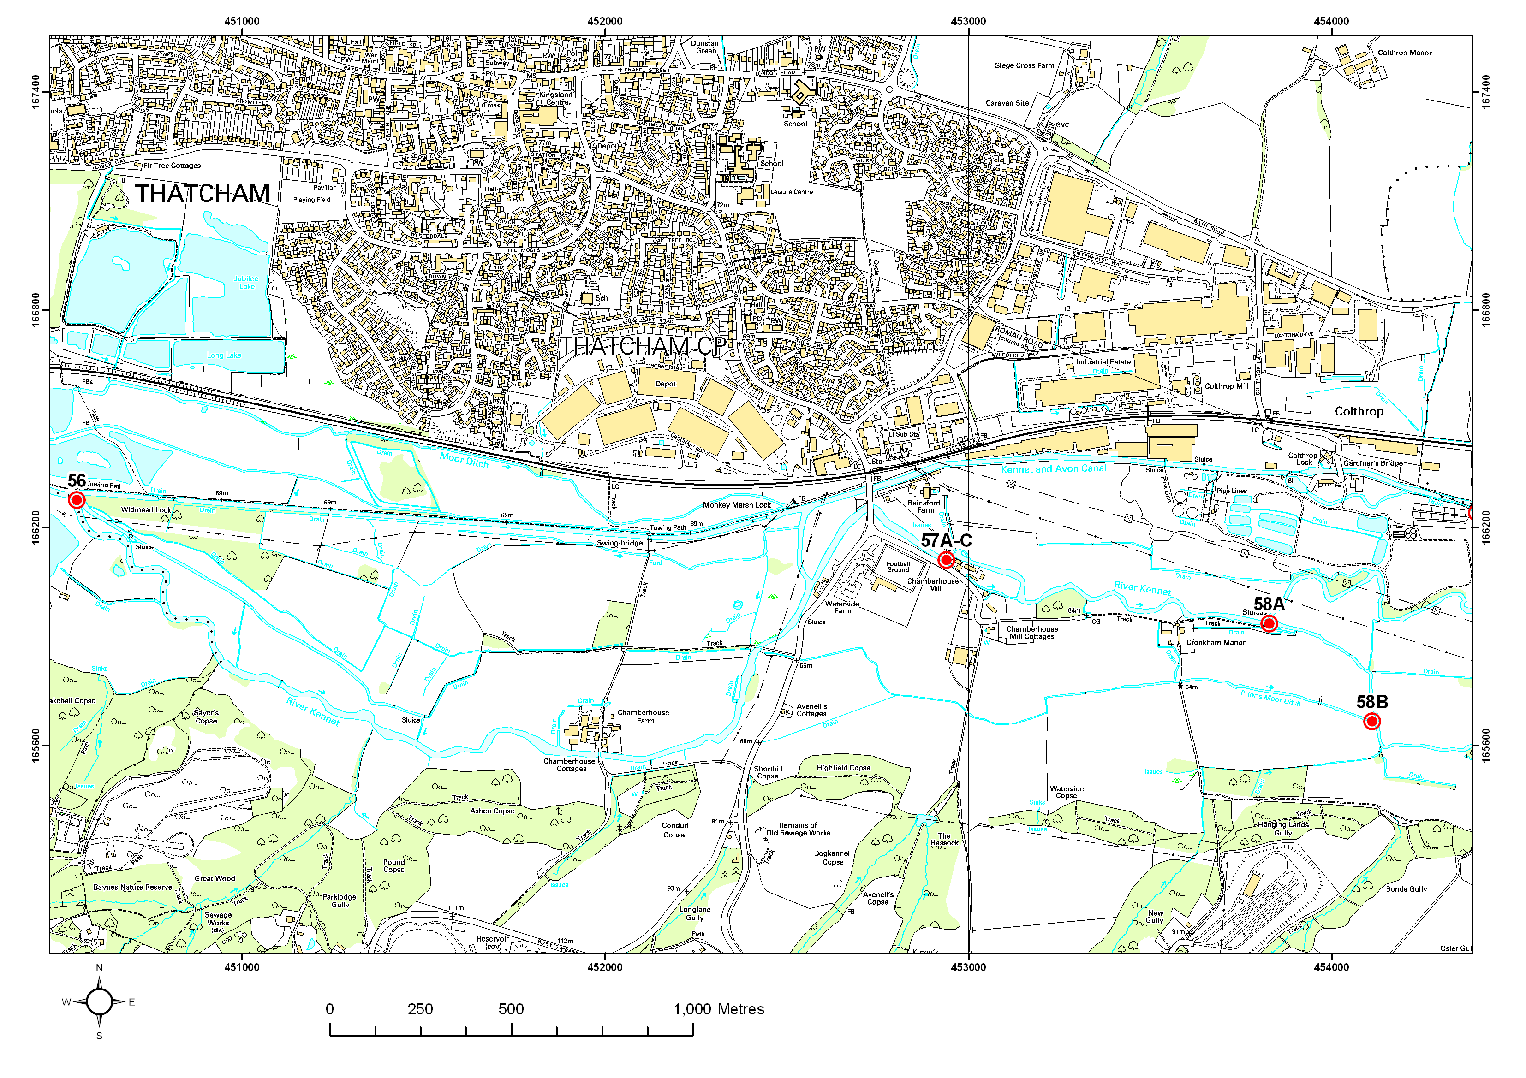
This map is reproduced from Ordnance Survey material with the permission of Ordnance Survey on behalf of the Controller of Her Majesty’s Stationery Office © Crown copyright. Unauthorised reproduction infringes Crown copyright and may lead to prosecution.
Figure 6.10 Structures 56 to 58 on the River Kennet
This map is reproduced from Ordnance Survey material with the permission of Ordnance Survey on behalf of the Controller of Her Majesty’s Stationery Office © Crown copyright. Unauthorised reproduction infringes Crown copyright and may lead to prosecution.
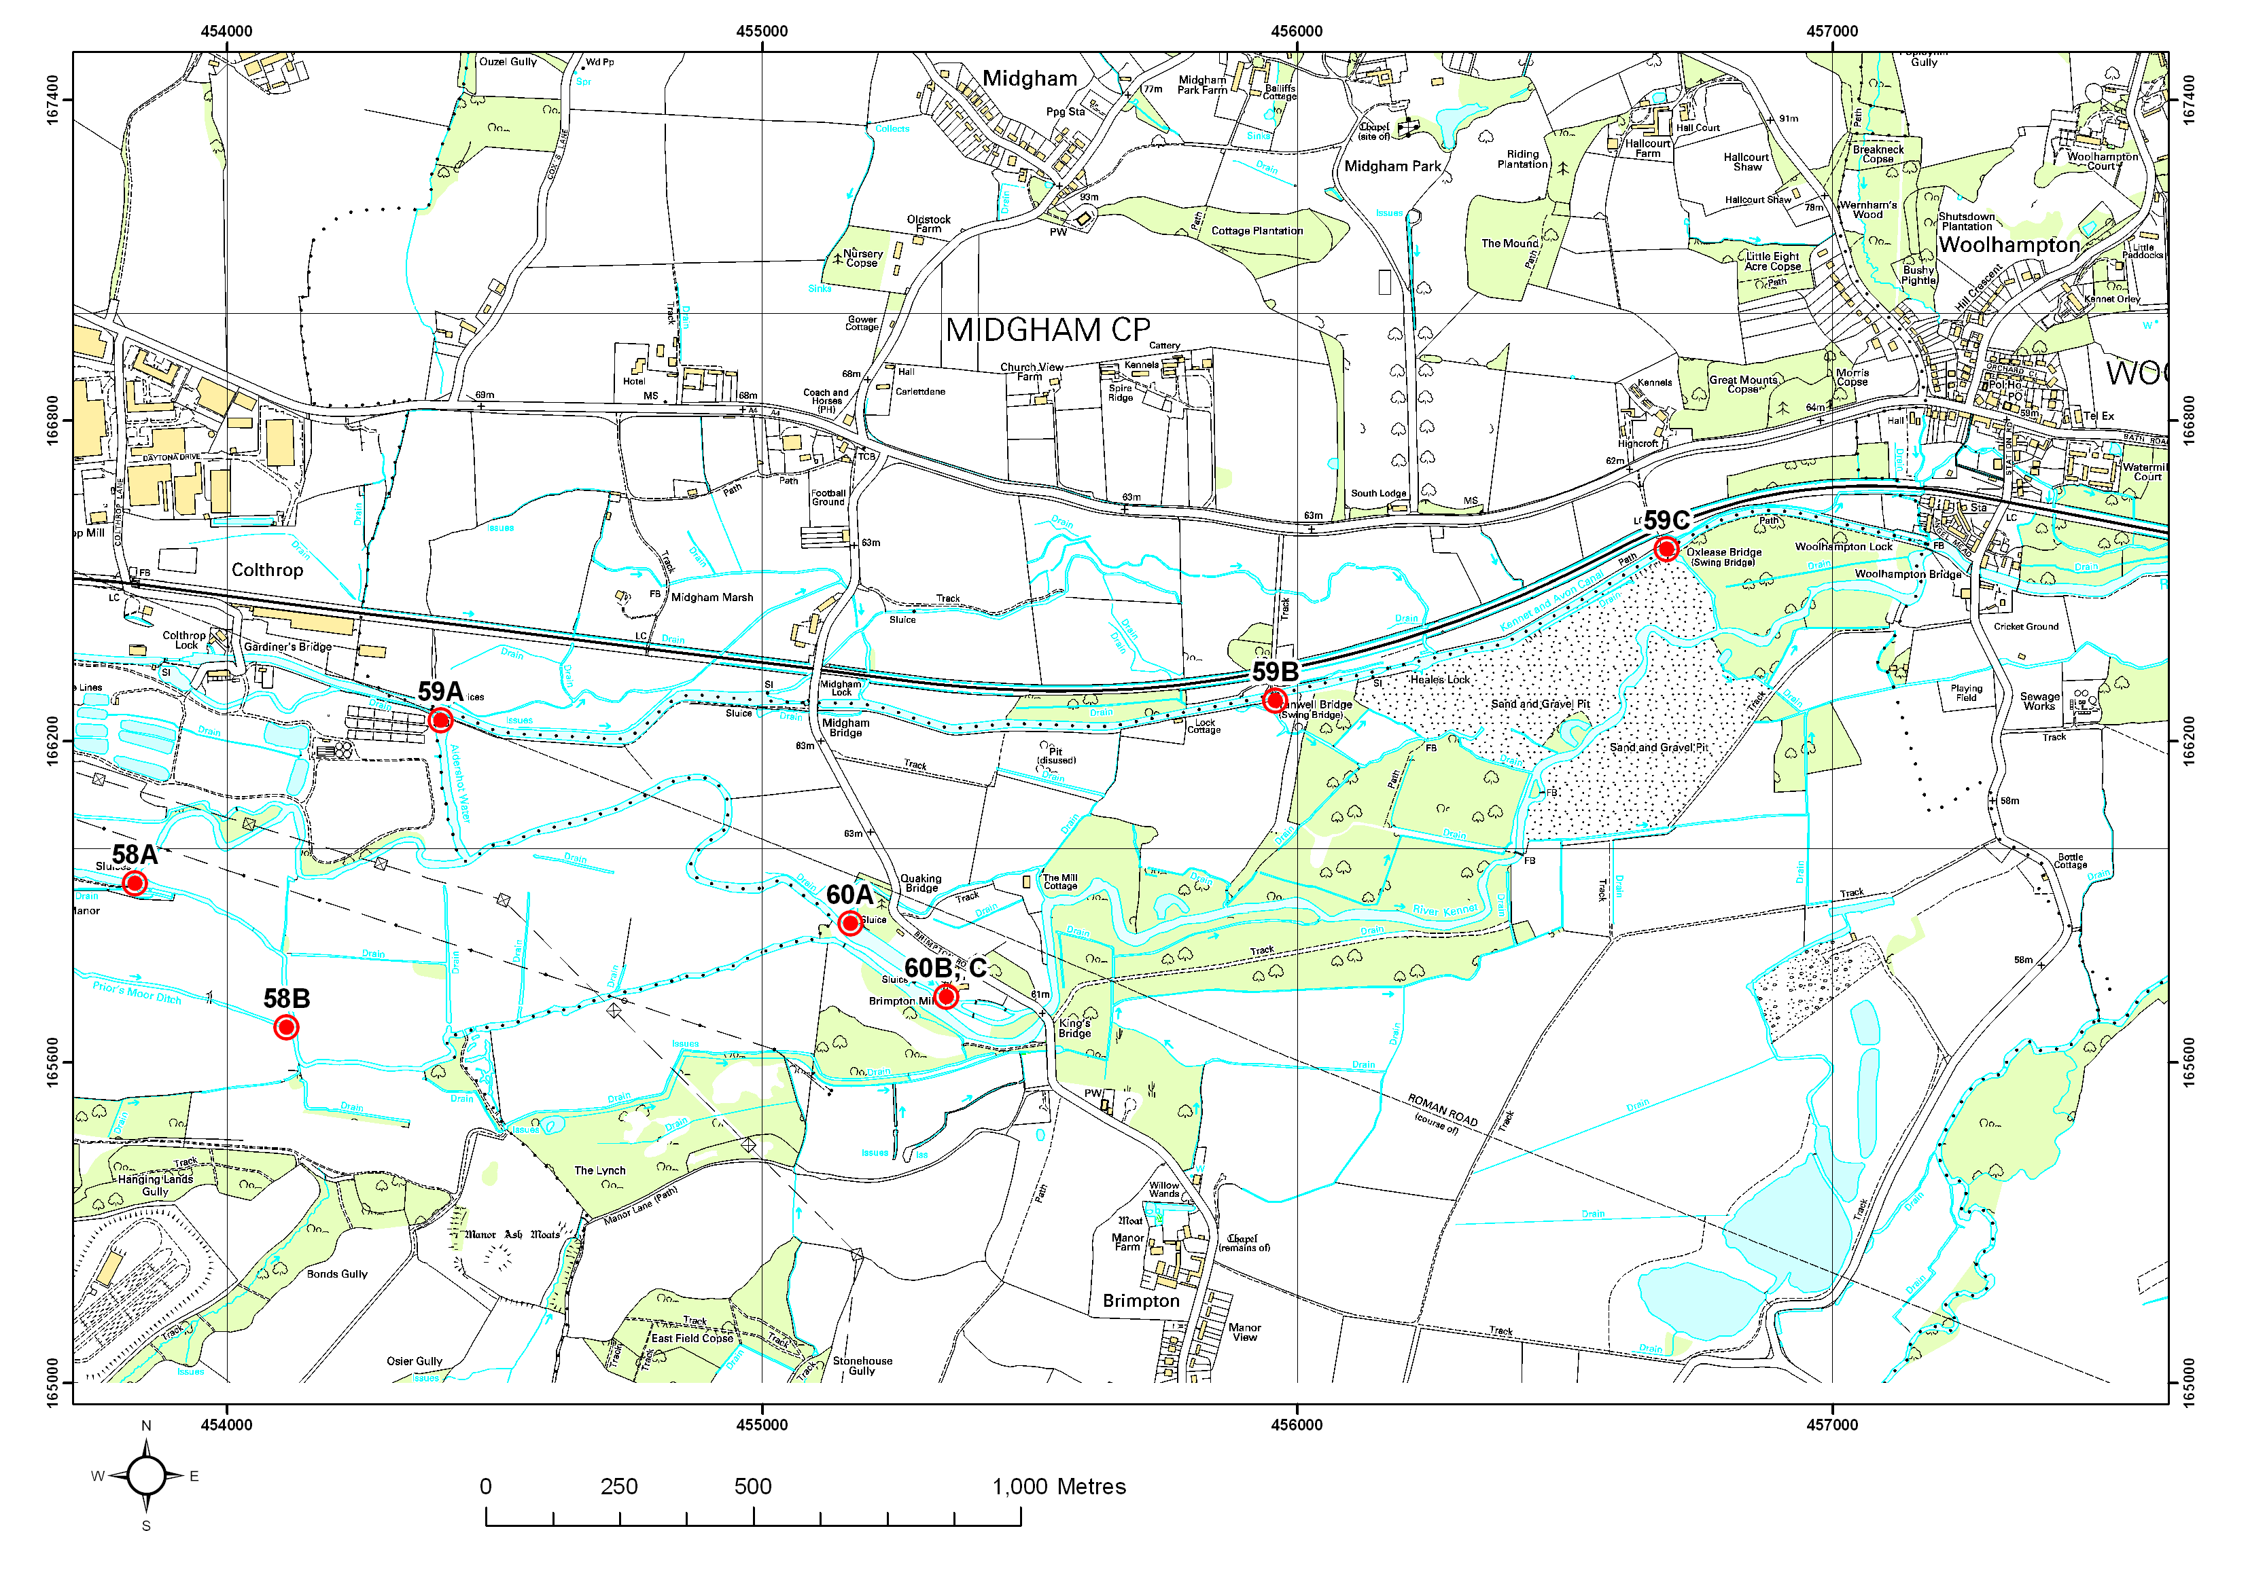
This map is reproduced from Ordnance Survey material with the permission of Ordnance Survey on behalf of the Controller of Her Majesty’s Stationery Office © Crown copyright. Unauthorised reproduction infringes Crown copyright and may lead to prosecution.
Figure 6.11 Structures 58 to 60 on the River Kennet
This map is reproduced from Ordnance Survey material with the permission of Ordnance Survey on behalf of the Controller of Her Majesty’s Stationery Office © Crown copyright. Unauthorised reproduction infringes Crown copyright and may lead to prosecution.

Structure ID 56
Priority | Low priority
Description | Dog’s Head Stakes, near Widmead Lock
Grid reference | SU505662
1999 WLMP comment | Currently a temporary gabion fixed structure with about 1 m head. Intended to be permanent structure and renovation forms part of Lottery funded works.
2006 Review comment | Structure is now a permanent fixed weir.
Comments from field visit | The purpose of the structure is to create elevated water levels upstream to stop boats grounding going through upstream lock (Bulls Lock). The structure is probably not the cause of unfavourable ecological condition which is probably due to the turbidity caused by the mixing of canal and river water. The structure doesn’t cause a large impoundment. Ideally the structure should be changed to a controllable sluice. If replaced, the setting of the new structure is very important to ensure water flows back into the Kennet rather than the canal.
Actions needed | BW may wish to replace this structure in the future and we should be looking to provide appropriate advice as required.

Structure ID 57A-C
Priority | Low Priority
Description | Chamberhouse Mill
Grid reference | SU529661
1999 WLMP comment | 57A: Mill. A residual flow is maintained in the turbine race controlled by a small notch with boards in the dam across the Mill head. Under the mill are two derelict sluices. There is a grill in front.  57B: A set of four buck gates of which the outer ones are manually controlled and the inner ones are automated. The maximum opening of this structure is 66.53 mAOD. The gates are alarmed to +50mm to Colthrop Mill which is permanently manned. The mechanical gates are hard to operate. There has been a problem with the automatic gates “hunting”. There is a possible interaction between this structure and the Colthrop Lock bypass sluice above the weir (59A). The gates (57B) are set to allow a small height of water over the sill (57C) but this is difficult to maintain in the summer and there is a shortfall of water to go in both directions. Higher water levels would cause problems at Chamberhouse and would necessitate that the banks be strengthened.  57C: A long (8 m) fixed weir with boards, sill level 66.4 m.
2006 Review comment | The mill creates an overwide and deep impounded upstream reach, which could probably be reduced if the mill was operated sensitively A fish pass was recently installed. There is good Ranunculus growth apparently in the upstream reach indicating the river is not affected too badly.
Actions needed | Agree the most beneficial management of structure.

Structure ID 58A
Priority | No Action Required
Description | Structures on the Crookham Manor Arm
Grid reference | SU538659
1999 WLMP comment | Off take below Crookham at the junction of the River Kennet and the Crookham Manor Arm. Three buck gates, two of which are automated. The bottom sluice level at maximum opening is 64.5 mAOD and there is a head of approximately 1 m. The construction of these sluices makes keeping them clear of debris very difficult.
2006 Review comment | Structure in poor state, with a 1 m drop. The river is not too badly affected and is flowing so not sure if anything can be done.
Actions needed | If the structure fails or emergency works are required in the future, consider best option. No immediate action required.

Structure ID 60B-C
Priority | Low Priority
Description | Structures at Brimpton Mill
Grid reference | SU556654
1999 WLMP comment | 60B: Overflow immediately upstream of the mill. This comprises a fixed weir, approximately 10 m wide with lasher boards which are put in position in the summer to retain a higher head above the structure. The head on the structure is approximately 2.5 m and the overflow joins the Crookham Manor Arm. A fish pass is to be installed here. The original sluices were removed by Thames Water Authority.  60C: Formerly a corn mill. The head of water retained at the original level by the original sill allowing a continuous flow. No levels data available.
2006 Review comment | The connectivity of the channels around here could be improved to achieve the principle of one uninterrupted channel of the river.
Actions needed | Consider proposals to improve channel connectivity.

Current site conditions

Natural England Condition Assessment

As stated in Section 1.2, the Natural England condition assessment had insufficient detail with which to identify the problematic structures on the River Kennet. However the information is useful to summarise the condition of the SSSI and the reasons for its classification as unfavourable.

The ecological condition of the River Kennet SSSI was last assessed by Natural England (NE) (formerly English Nature) in July 2002. Table 6.2 presents the condition assessment categories and their definition. A total of 4 reaches were surveyed and found to be in ‘unfavourable no change’ condition.

The reasons cited for the unfavourable ecological condition of the River Kennet SSSI were as follows:
- Fish stocking;
- Inappropriate weirs, dams and other structures (channel modification);
- Invasive freshwater species;
- Siltation;
- Water abstraction; and
- Water pollution – agriculture and urban run off and discharges from sewage treatment works.

Not all of these reasons can be tackled through the WLMP process: only those which affect water levels can be considered. These include “inappropriate weirs, dams and other structures”, and as a result of this, some “siltation” issues can also be addressed.

Water Quality
For the purposes of the Water Level Management Plan, water quality needs to be considered where it may impinge upon the ability to manage water levels to promote favourable ecological condition, or where it is relevant to the SSSI of interest. Overall the water quality of the SSSI is considered to be good although phosphate levels are above the chalk river target of 0.06 mg/l.

The water quality of the river is only of concern to this WLMP where the presence of water level control structures is causing suspended sediment to become deposited on the river bed. It is expected that the proposed changes to structures, as discussed in Section 8 and 10, will help alleviate problems of sedimentation.

Table 6.1 The Natural England Condition Assessment for the River Kennet SSSI

Main habitat | Unit | Area (ha) | Latest assemt | Assesmt descriptn | Condition assessment comment | Reason for adverse condition
Rivers and streams | 1 | 37.56 | 25 Jul 2002 | Unfavourable no change | Turbidity and loss of aquatic macrophytes attributed to discharge from Marlborough Sewage Treatment Works over about 1 km of upper part of stretch. P concentrations >0.1 mg/l. There is also likely to be a diffuse pollution contribution from upstream of Marlborough but difficult to disassociate from contribution of sewage treatment works. Fishery management appears to be sensitive and sympathetic but several control structures in place which may be restricting fish movement. Ranunculus rather patchily distributed but reasons unclear - possibly mostly related to flow conditions. Concern surrounding influence of Axford abstraction on flows. | Fish stocking, inappropriate weirs dams and other structures, invasive freshwater species, siltation, water pollution - agriculture/run off and discharge
Rivers and streams | 2 | 45.70 | 24 Jul 2002 | Unfavourable no change | Increased turbidity and reduced aquatic plant abundance attributed to effects of discharge from Hungerford Sewage Treatment Works affect a significant reach. Connections with the Kennet and Avon Canal gives rise to significantly increased turbidity and loss of aquatic macrophytes. P concentrations >0.06 mg/l. Likely to be a diffuse pollution influence from above Marlborough but difficult to untangle from influence of sewage treatment works and the Canal. A large section at Avington is clearly not meeting objectives due to heavily modified channel morphology (over deepened and overwidened). | Fish stocking, inappropriate weirs dams and other structures, invasive freshwater species, siltation, water pollution - agriculture/run off and discharge
Rivers and streams | 3 | 16.90 | 24 Jul 2002 | Unfavourable no change | Frequent connections with Kennet and Avon Canal in this stretch give rise to significant turbidity and siltation problems. Aquatic plant growth is very limited. Hard river banks are a prominent feature and there are numerous structures which may be preventing fish movement. Newbury sewage treatment works also likely to be a polluting influence (inc. past problems with storm discharges). Contribution of urban run-off unclear but may be important. | Invasive freshwater species, siltation, water pollution - agriculture/run off and discharge
Rivers and streams | 4 | 11.38 | 24 Jul 2002 | Unfavourable no change | Upstream connections with Kennet and Avon Canal give rise to significant turbidity and siltation problems. Aquatic plant growth is limited. Upstream influence of Newbury sewage treatment works and urban run-off on water quality may also be significant. | Invasive freshwater species, siltation, water pollution - agriculture/run off and discharge
Source: http://www.english-nature.org/special/sssi/reportAction.cfm?report=sdrt13&category=S&reference=2000164

Water level management objectives and proposals

Water level management objectives

Natural England objectives

Natural England has published guidelines detailing the optimal water regime for Chalk rivers. As it is extremely difficult to provide a water level regime for rivers and/or in-channel features; the recommended approach is to focus on the optimal flow regime for chalk rivers based on naturalised flow (i.e. the river should hold 90% of naturalised flow, i.e. total abstraction should not exceed 10%).

Natural England has defined the ecological and hydrological regime required to meet favourable condition for chalk rivers (JNCC, 2005). The regime is described according to optimal river flows, substrate, structure and human actions as listed below:

- Flow regime: This should be characteristic of the river. As a guideline, at least 90% of the naturalised daily flow should remain available to the river throughout the year;
- Substrate: No excessive siltation should occur and there should be no evidence of excessive algal cover;
- Habitat structure: Channel form should be characteristic of river type with predominantly unmodified planform and profile. Bank and riparian zone vegetation structure should be near-natural. There should be minimal impact on river flow from in-channel structures;
- Plant community: In-channel vegetation of the river dominated by characteristic species;
- Non-native/introduced species: No impact on native biota from non-native or introduced species; and
- No artificial barriers significantly impairing characteristic migratory species from essential life-cycle movements. Barriers may take the form of weirs, barrages or intakes/off-takes that entrain characteristic species.

Working principle for the River Kennet WLMP Review
As stated in Section 1.2.1, the following working principle was agreed by Natural England and the Environment Agency for the River Kennet SSSI WLMP Review:
Aim to ensure at least one continuous stretch of channel in favourable condition with no barrier to fish migration.

Water level management proposals

The list of problem structures discussed in Section 6.2.1 cannot all be tackled within this WLMP Review prior to the deadline of 2010. The problem structures have been classed into ‘Priority’ and ‘Non-priority’ according to the need for immediate attention.

The proposals fall into three main types of changes:
- Change in management / management agreement;
- Removal and/or replacement of the structure; and
- River restoration (as part of the above two options).

Change in management / management agreement
Identifying the current management of structures is difficult as generally most are done on an ad-hoc basis. Where a change in management is identified for a structure, this means keeping the structure open (or raising hatches etc.) allowing water and fish to move through easily, therefore removing the impacts of impoundment. As long as a continuous length of channel with unimpeded flow can be achieved a compromise will be reached.

Removal or replacement of the structure
The removal of a structure should occur where the structure serves no active purpose, creates an impounding effect that is having a significant impact on the ecology, and where operating the structure in a more sensitive manner will not substantially remove this impact. The replacement of a structure should occur when it cannot be removed for varying reasons (e.g. if the structure is a gauging weir) but where alterations are needed to allow fish passage. The alterations could involve a change in management e.g. removal of boards or the raising of hatches, or replacing part or all of the structure with one that allow fish passage such as replacing a overshot weir with an undershot structure.

River restoration
Wholesale river restoration per se, cannot be considered within a WLMP which, for the River Kennet, serves to focus upon water level control structures in the river. However where a structure is identified as requiring a change in management, or total removal, this will usually also require river restoration works in the form of channel narrowing and/or bed reprofiling. This is because the structures identified for management changes or removal cause impoundment of water to a certain length upstream. Restoration would be needed to ensure that, following the removal of the structure, the channel size is appropriate to achieve good quality chalk river habitat.

Table 8.1 summarises the list of actions identified for the River Kennet WLMP structures together with priority and responsibility.

Table 8.1 Changes needed for the problem structures, priority and responsibility
Note that those structures with no actions are not included
ID no | Location | Type of changes required | Detail | Responsibility | Priority?
1 | Elcot Mill, Marlborough | Structure restoration/ removal | Consider the benefits of restoring the structure to open up the back channel for the benefit of brown trout and associated chalk river features | EA/NE/landowner | Low priority
3C | Werg Mill, Mildenhall | Change in management | Change in management to allow more water through the structure, and renovation of the structure if necessary. | EA/NE/landowner | Low-priority
4A, 4C | Durnsford Mill, Mildenhall | Change in management and river restoration | Feasibility study to investigate the options to restore the river bed to pre-dredging condition, changes in management and channel enhancement to improve flow and fish habitat | EA/NE/landowner | Low-priority
5A-C | Stitchcombe Mill | Change in management | Change in management and reinstatement of side sluices to allow flow down the side channel, and associated river restoration. | EA/NE/landowner | Low-priority
6 and 8 | Kings Drive, Axford | Structure removal | Structure 6 needs to be replaced or renovated and Structure 8 removed. Fencing should be installed to prevent cattle access to the channel to the south. | EA/NE/ landowner | Low-priority
7A | Red Lion Hatches, Axford | Structure removal | Remove the structure and restore river channel. Changes to Structure 7A should be made with consideration of changes to Structure 9 (below). | EA/NE/landowner | Low-priority
ID 9 (10B/C) | Rags Hatches Axford | Change in management or structure removal | A feasibility study is needed to examine options for improving the river through changes in structure management/removal, restoration (including narrowing and bed re-levelling) and increased fish passage. It is essential that enough water passes along the higher level channel and through Priory Farm to maintain a supply for the artificial lake within the grounds. | EA/NE/landowner | Priority
11B and /or C | Offtake to Ramsbury Lake | Change in management | Change in management to retain more water in the river and associated river restoration. The bypass channel would need works to it to improve the habitat. Changes to these structures should be made with consideration of changes at Structure 12. | EA/NE/landowner | Priority
12 | Outfall from the Ramsbury Lake | Change in management | Manage in conjunction with changes agreed to operation of lake offtake. Use of a boom is suggested to prevent algal build-up on the lake discharging into the Kennet | EA/NE/landowner | Low-priority
14A | Moons Mill, Ramsbury | Change in management | Agree an operating procedure for the new and existing structures to try and relieve the impounding effect. This would be done in association with upstream restoration works. Investigate methods of fish passage. | EA/NE/landowner | Low-priority
15A-C | Ramsbury Mill (u/s of Howe Mill) | River restoration | A feasibility study is required to investigate the options available to significantly reduce this impoundment, including using a by-pass channel to avoid the mill, and bed and bank re-profiling to enhance the chalk river features. | EA/NE/landowner | Priority
17 | Sluice by West Lodge | Management agreement | Management agreement. Possible restoration of carrier streams | EA/NE/landowner | Low-priority
19 A-G | Littlecote Fish House | Change in management and river restoration | A feasibility study is required to fully explore possible options for restoring the river, the need for narrowing works, the optimal water level and to liaise with local landowners. Need to investigate how a change in operation of the main weir at the pump house would affect the upstream reach, how much channel work would be required, and the possibility of making fish passage available via one of the channels. Any changes should consider the potential effect upon the water levels of Chilton Foliat Meadows SSSI (see the WLMP for that site). | EA/NE/landowner | Priority
20B, 21 | Between SU316703 and Chilton Foliat Mill | Change in management and river restoration | A feasibility study is required to fully explore possible options for changing the split in flow, opening the blocked channel downstream of the weed rack and river restoration. Any changes should consider the potential effect upon the water levels of Chilton Foliat Meadows SSSI (see the WLMP for that site). | EA/NE/landowner | Priority
22, 23 25B, 25E to H/I | Chilton Estate | Change in management and river restoration | A feasibility study is required to maximise the potential of the river through this estate. This is likely to include agreeing the best operating methodology to try and establish at least one chalk stream channel in favourable condition. This channel should have unrestricted fish access. | EA/NE/landowner | Priority
26A-E | Eddington Mill | Management agreement | A feasibility study is required to investigate the management and condition of the mill structure, determine management responsibilities and get a management agreement in place. Options to consider include sending more water down the channel which flows south of the lakes; this would help increase the gradient and remove the impounding effect of the main mill. It may also be an option to replace the side structure at the mill to allow more flow and fish passage. It is critical to maintain flow down the ‘waste stream’ as this is a major feed for Eddington Meadows which is a component part of the Kennet and Lambourn Floodplain SAC and SSSI | EA/NE/landowner | Priority
27C | Eddington Bridge to Brackets Hatches | Management agreement | Management agreement to minimise any impact on the river and conflict over the flow split. | EA/NE/landowner | Low-priority
28B | Denford Mill | Management agreement | Operating agreement to minimise any impact on the river and conflict over the flow split. | EA/NE/landowner | Low-priority
30 | Avington No 1 | Change in management and river restoration | A feasibility study is required to examine the effects of proposed changes in management of the structure on the upstream reach, and the need for river restoration. In addition the impact to adjacent landowners should also be investigated. | EA/NE/landowner | Priority
31A and B | Avington Fishing Hut | Change in management and river restoration | Review of the existing feasibility study into the options to change the current flow split to encourage more water to flow down the back SSSI channel, river restoration and management agreement. | EA/NE/landowner | Priority
32A-B | Main structures at Avington | Change in management | If the SSSI side channel can be used (fed from structure 31A), as the main SSSI channel then the operation of these structures become important in maintaining a head in the canalised reach. Operating agreement would need to be produced in conjunction with the changes upstream. | EA/NE/landowner | Low-priority
32D | Weed rack upstream of Barton Court | Structure removal | Remove or alter structure and assess degree of upstream restoration that would be required. | EA/NE/landowner | Priority
33A | Upstream of Kintbury water meadow | Structure removal | Remove the structure | EA/NE/landowner | Low-priority
33B-D | Sherman’s Hatches | Management agreement | Consider changes to the operation of the structures to reduce input of flow to the canal in the winter months. | EA/NE/landowner | Low-priority
36B | Kintbury Water Meadows | Management agreement | Management agreement | EA/NE/landowner | Low- priority
38A-B | Barton Holt | Structure removal | Remove weir and find alternative feed for the lake via an existing channel that runs parallel to the river. Advanced plans are currently being drawn up. | EA/NE/landowner | Priority
46A-E | Downstream of Hamstead | Change in management | Change in management and river restoration | EA/NE/landowner | Low-priority
48A | Barnetts Hatches | Management agreement | Continue existing management. Flows must be maintained down to the lake, and from the lake into stream which feeds the SAC. Further advice has now been given to the owners of Benham Estate on the operation of the relevant structures. | EA/NE/landowner | Low-priority
51B | Downstream of Barnett Hatches | Change in management | A feasibility study is required to assess the options to minimise the impact on the river while retaining the historic interest of the structures and the bathing pool, and the need for river restoration. | EA/NE/landowner | Low-priority
56 | Dogs’ Head Stakes, near Widmead Lock | Structure replacement and management agreement | British Waterways may wish to replace this structure in the future and the Environment Agency should provide appropriate advice as required | EA/NE/landowner | Low-priority
57A-C | Chamberhouse Mill | Change in management | Agree the most beneficial management of structure. | EA/NE/landowner | Low-priority

Constraints and impacts on adjacent ground
Any constraints or impact that may arise as a result of changes to structures, or that may affect the possibility of making changes have been discussed with the particular structure account in Section 6.2.1.

There are some disputes between adjacent landowner regarding flow splits in the river: these are presented in Section 14.

Alterations to infrastructure and procedures

Actions from the 1999 WLMP

Table 10.1 presents the original list of actions from the 1999 WLMP and whether or not the actions have been undertaken. The table also shows if the outstanding actions are considered priority to include in this Review cycle.

Actions arising from the WLMP Review

The list of actions outlined in Section 8 has been prioritised into actions that should be undertaken within this Review cycle of the WLMP. Table 10.2 presents the list of actions arising from the 2006 WLMP Review.

Table 10.1 Alterations needed to water courses, structures and procedures from the 1999 WLMP

Location | Change needed to: | Detail | Responsibility | Implemented? | Priority for further attention?
Avington and Barton Court | Watercourse | Assessment of the potential for channel narrowing and flow variation within the main Kennet at Avington and at Barton Court and implementation if feasible. | EA/Landowners (Hungerford Park Estate, Hills Ltd, Mr Bailey). | Feasibility study completed but not implemented. | Study will be used to guide current action for Priority Structures 30-32
Newbury | Structures | The majority of the structures in Newbury are owned and operated by British Waterways for navigation. The Environment Agency and British Waterways are working towards an agreed operating plan that will meet the needs of flood defence and navigation. | EA /British Waterways | Yes operating protocol agreed | n/a
Lamb Stream | Structures | Review of the structural stability of the aqueduct carrying the Kennet over the Lamb Stream. | EA /British Waterways/Sir Peter and Lady Michael. | No | Low priority
Hamstead Marshall | Structures | Discussions need to take place on the funding of the replacement of the structures at Hamstead Marshall. Following this the works should be programmed and undertaken. | EA /British Waterways/Sir Peter and Lady Michael | Yes | n/a
Dreweats Lock | Structures | Renovations of the overflow structures at Dreweats Lock need to incorporate provision for a continuous flow through the structure to feed the back channel to the Dundas’ land. This may be by a split paddle or V notch. | British Waterways | No | Low priority
Dog’s Head Stakes | Structure 56 | Discussions should take place between British Waterways (BW) and the Environment Agency regarding the provision of a V notch on the refurbished Dog’s Head Stakes and the finished level of the structure. | British Waterways/ EA | No. Agreed criteria for new structure but BW funding was not forthcoming. In | Low priority
Benham weir | Procedures | Implementation of the agreement reached between British Waterways and the Environment Agency that one sluice on Benham weir (47A) will be maintained open to between 5-10 cm at all times, the precise level to be determined by experimentation over the next two years. The effectiveness of this will be reviewed each year. During exceptional low flows, regular consultation will take place between British Waterways and Benham Estate to ensure that each is appraised of the others requirements. | British Waterways (with EA and Benham Estate) | Yes: ongoing. | Low priority
Back pumping at key locations on the SSSI | Procedures | A feasibility study is required to assess the benefits and justification for the introduction of back pumping at key locations on the SSSI in order to reduce adverse effects on the SSSI caused by the desire to maintain navigation in the canal during low flow years. | British Waterways with assistance from the EA and English Nature | No, but EA are monitoring the flow distribution which suggests this is not a priority action. | Low priority
Sherman’s Hatches and the overflows from the canal | Procedures | The current procedures which have been formally agreed as part of this Water Level Management Plan for the operation of Sherman’s Hatches and the overflows from the canal (42, 44) which are detailed below need to be followed. A review of these needs to be undertaken bi-annually.  Sherman’s Hatches (Structure 33B). A bank of 6 metal hatches, each approximately 1m wide controlling the flow of water from the Kennet to the canal. The gradient between the two is very shallow. In times of high flow the hatches are opened to release water to the canal. In low flows, water from the canal may feed into the river and the hatches are then shut down to prevent this occurring.  Dundas overflow (Structure 42A). This weir has boards in it raising the spillway by 10 cm. In summer no flow comes over the structure and in winter the boards are released to allow excess water to pass down the Dundas.  Dreweats Lock (Structure 42B). This is the principal overflow on the stretch of the canal and comprises a fixed weir and lasherboards with a head of 1.5m. At high flows 1 – 2 boards are drawn to lower the levels in the canal. Adjacent to the weir is a set of seven wooden hatches, each approximately 1m wide. In general, the overspill copes with the normal flows but in high flows the boards may be removed or the sluices opened. They are operated to keep the canal to within a 10 cm band of operation. | British Waterways/ EA | Yes: ongoing. Need to revisit operating agreement in light of Kennet Chalk Stream project investigation into impacts of turbidity | Low priority

Table 10.2 Priority alterations needed to water courses, structures and procedures from the 2006 WLMP Review

ID no | Location | Type of changes required
ID 9 (10B/C) | Rags Hatches Axford | Change in management or structure removal
11B and /or C | Offtake to Ramsbury Lake | Change in management
15A-C | Ramsbury Mill (u/s of Howe Mill) | River restoration
19 A-G | Littlecote Fish House | Change in management and river restoration
20B, 21 | Between SU316703 and Chilton Foliat Mill | Change in management and river restoration
22, 23 25B, 25E to H/I | Chilton Estate | Change in management and river restoration
26A-E | Eddington Mill | Management agreement
30 | Avington No 1 | Change in management and river restoration
31A and B | Avington Fishing Hut | Change in management and river restoration
32D | Weed rack upstream of Barton Court | Structure removal
38A-B | Barton Holt | Structure removal

Other Proposed Action
There are no other proposed actions.

Contingency Measures
There are no contingency measures.

Unresolved Issues
Actions outstanding from the 1999 WLMP are detailed in Section 10.1.

Other Matters
There are three areas of dispute over water rights and the split in flow between certain structures and channels. Settling these disputes falls outside the remit of the WLMP but they should be noted with this Review, as the dispute may affect the ability to reach a management agreement over the structures affected. The Environment Agency has been asked to chair meetings to resolve two of the disputes.

The three areas of dispute are:

- Bracket Hatches (Structure 27C, d/s of Hungerford). The flow split created by the management of this structure is the focus of a dispute between Hungerford Town Manor and the landowners Wilsons. The Environment Agency have been asked to chair a meeting to resolve management issues;
- Benham Lake (Structure 48A). There is a dispute between the owners of the Lake and the Sutton Estate. The Environment Agency have been asked to broker a management agreement over the volume of water movement from SSSI channels to the lake; and
- Ramsbury Manor Estate (Structure 11 A-D). It is thought that too much water flows into the Lake at the expense of the bypass channel which, at low flows, can be starved of water. The landowner has been approached but seems disinterested and unwilling to make any changes to the current management. Note that this dispute is highlighted up within this Review as a non-priority action for change.

Consultees
No formal consultation has taken place with landowners regarding change to structures within this WLMP Review.

It will be necessary to enter into discussion with landowners for their views on any aspects of water management relevant to the structure under investigation in the next stages of the WLMP process.

References
Andrews Ward Associates (1999) Water Level Management Plan for the River Kennet SSSI. Report to the Environment Agency.
Dunbar, M. (ed.) (2002) Heavily Modified Waters in Europe: Case Study on the River Kennet. Case Study submitted by the Environment Agency of England & Wales and the UK Government Department for Food, Environment and Rural Affairs to the EU WFD CIS.
Defra and English Nature (2004) Achieving the Public Service Agreement Target for SSSIs; a review of the contribution of WLMPs. Department for Environment, Food and Rural Affairs.
JNCC (2005) Common Standards Monitoring Guidance for Rivers Version March 2005. Available from <http://www.jncc.gov.uk/pdf/CSM_rivers_Mar05.pdf> Last accessed November 2006.

Appendices

Appendix A – SSSI Citation

COUNTY: BERKSHIRE/WILTSHIRE SITE NAME: RIVER KENNET

Status: Site of Special Scientific Interest (SSSI) notified under Section 28 of the Wildlife and Countryside Act 1981

Local Planning Authorities: Berkshire County Council, Wiltshire County Council,
Newbury District Council, Kennet District Council

National Grid Reference: SU203692 to SU572667

Ordnance Survey Sheet 1:50,000: 174 1:10,000: SU26 NW, SU27 SW, SU27 SE, SU37 SW, SU36 NW, SU36 NE, SU47 NW, SU46 NE, SU56 NW, SU56 NE

Date Notified (Under 1981 Act): 1 November 1995 Date of Last Revision: -

Area: 112.72 ha

Other information: The River Lambourn, which is a tributary of the River Kennet, is also an SSSI. There are two existing SSSIs along the River Kennet: Freemans Marsh and Chilton Foliat Meadows. The site boundary is the bank top or, where this is indistinct, the first break of slope.

Description and Reasons for Notification
The River Kennet has a catchment dominated by chalk with the majority of the river bed being lined by gravels. The Kennet below Newbury traverses Tertiary sands and gravels, London Clay and silt, thus showing a downstream transition from the chalk to a lowland clay river. As well as having a long history of being managed as a chalk stream predominantly for trout, the Kennet has been further modified by the construction of the Kennet and Avon Canal. In some places the canal joins with the river to form a single channel. There are also many carriers and channels formerly associated with water meadow systems. The river flows through substantial undisturbed areas of marshy grassland, wet woodland and reed beds.

The flora of the River Kennet is species-rich and diverse, having the highest average number of species per site surveyed of any other lowland river in Britain. The Kennet shows a clear downstream succession in plant communities reflecting variations in geology and flow rate as well as the influence of the canal. The flora is considered to be intermediate in character between the classic chalk rivers of the south and the oolitic rivers to the north. Stream water-crowfoot Ranunculus pencillatus, starwort Callitriche obtusangula and watercress Nasturtium officinale dominate the upper half of the river where shallow water and gravel are typical. In the slower, deeper water found downstream a much wider range of species occurs. This includes four species of pondweed (Potamogeton spp.) and horned pondweed Zannichellia palustris. Other plants occurring here include spiked water-milfoil Myriophyllum spicatum, yellow water-lily Nuphar lutea, common club-rush Scirpus lacustris and bur-reed species Sparganium. Below Newbury there is a larger volume of water and less chalk influence and river water-crowfoot Ranunculus fluitans occurs for the first time. River waterdropwort Oenanthe fluviatilis, a nationally scarce species of larger chalk streams, has been recorded from the mid to lower Kennet.

Aquatic invertebrates are abundant and the Kennet is especially noted for its large hatches of mayflies (Ephemeroptera), including Ecdyonorus insignis and Ephemerella notata which have a very local distribution. These are associated with moderately flowing water in calcareous areas. Also worthy of mention are the beautiful and banded demoiselle damselflies, Calopteryx virgo and C. splendens respectively. The nationally scarce cranefly Molophilus niger (the larvae of which live in vegetated stream and riverside) has been recorded from the Kennet. The caddis fly Ylodes conspersus also ranked as nationally scarce, has also been found along the river.

The Kennet supports good populations of kingfisher, grey wagtail, mute swan and little grebe, as well as sedge and reed warblers. Common sandpiper and redshank frequently use this river on passage. The Kennet has a varied and mixed fishery including healthy, self-sustaining populations of wild brown trout, grayling, perch, chub, dace, roach, pike, gudgeon and bullhead.

Would you like to find out more about us, or about your environment?

Then call us on
08708 506 506 (Mon-Fri 8-6)

email
enquiries@environment-agency.gov.uk

or visit our website
www.environment-agency.gov.uk

incident hotline 0800 80 70 60 (24hrs)
floodline 0845 988 1188 (24hrs)

Favourable condition means the SSSI is being adequately conserved and is meeting its conservation objectives; however, there is scope for enhancement of these sites.
The Views about Management for the River Kennet SSSI can be viewed on the following webpage: http://www.english-nature.org/special/sssi/sssi_details.cfm?sssi_id=2000164
The River Kennet SSSI citation and conditions assessment can be found on the Natural England webpage: http://www.english-nature.org.uk/special/sssi/sssi_details.cfm?sssi_id=2000164
‘Unfavourable no change’: The special interest of the SSSI unit is not being conserved and will not reach favourable condition unless there are changes to the site management or external pressures.

